What Happens to a Substance in a Physical Change?
- A _______________ change alters the form or _______________ of _______________ but does not turn any _______________ in the matter into a _______________ substance.
- A _______________ that undergoes a _______________ _______________ is still the _______________ substance _______________ the change.
- Examples include: _______________ _______________ into water, a tree being cut _______________, and ice _______________ on a _______________.
Changes of State
- The _______________ states of _______________ are: _______________, _______________ and _______________.
- _______________ is an example of a _______________ change. _______________ water changed state and became _______________ _______________ and mixed with the _______________.
- When _______________ changes state it is an example of a _______________ change.
Changes in Shape or Form
- Another way that a _______________ change can take place is by _______________ it as well as _______________, _______________, _______________ and _______________ matter.
- We know the _______________ a substance is a _______________ change because if we evaporate the water there is a crust of _______________ left _______________.
- Close examination shows us that the crust left is actually the _______________ that was _______________ to _______________ with.
- Therefore a _______________ change took place and the substance only changed _______________ or _______________.
What Happens to a Substance in a Chemical Change?
- A _______________ in matter that produces one or more _______________ substances is a _______________ change or _______________ _______________.
- In some _______________ changes, a single substance _______________ down into two or more _______________ substances.
- For example, _______________ _______________ breaks down into _______________ and _______________ _______________.
- In other chemical changes, two or more substances _______________ to form different _______________.
- For example, _______________ is a natural chemical change. Several _______________ combine with _______________ from the sung to _______________ new substances.
Chemical Changes used everyday
- Some _______________ changes are used in _______________ to collect _______________.
- _______________ uses super strong glues to make _______________ more _______________.
- The _______________ is heated to a _______________, and the vapor combines with _______________ and other body chemicals to form a _______________ powder.
- _______________ is a chemical that reacts with _______________.
- It combines with traces of _______________ that are too small to see and creates a substance that _______________ in the _______________.

Examples of Chemical Change
- One common _______________ change is the _______________ of natural gas on a _______________ stove.
- _______________ gas is mostly made up of the _______________ _______________ (CH4).
- When _______________ burns it combines with _______________ in the air and forms _______________ substances.
- The new substances that form include _______________ _______________ _______________ (CO2) and _______________ _______________ (H2O).
- Each substance can be _______________ by their _______________, which are different from those of _______________.
- The chemical changes that occurs when _______________, such as _______________ _______________, _______________ _______________, or _______________, burn in air is called _______________.
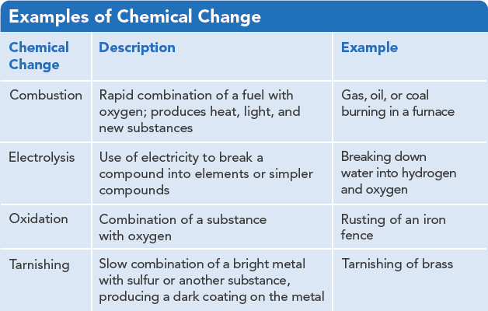
Conservation of Mass
- In the late 1770’s the French Chemist, _______________ _______________, measured _______________ both _______________ and _______________ a chemical change.
- His data showed that _______________ _______________ was _______________ or _______________ during the change.
- The fact that matter is not _______________ or destroyed in any _______________ or _______________ change is called the law of _______________ of _______________.
- If you could measure all of the _______________ _______________ and water produced when _______________ _______________ you would find that it _______________ the _______________ of the _______________ _______________ plus the mass of the _______________ from the atmosphere.
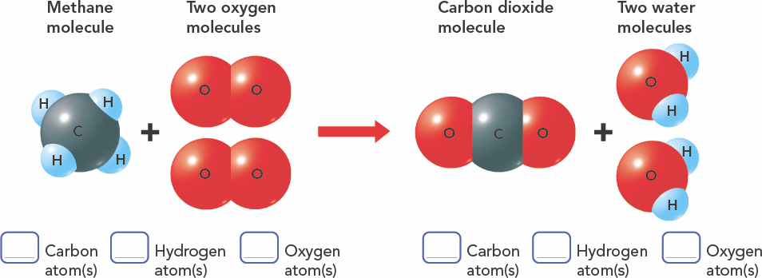
How are Changes in Energy and Matter Related?
- _______________ is the ability to do _______________.
- Every _______________ and _______________ change in matter includes a _______________ in _______________.
- When _______________ changes to _______________ water, it _______________ energy from the surrounding _______________.
- When candle wax burns, it gives off _______________ as _______________ and _______________.
- Like matter, _______________ is never _______________ or _______________ it only changes _______________.
Temperature
- Think about how it feels when you walk into an air conditioned building on a really hot summer day. Think of the _______________ _______________.
- _______________ is a measure of how hot or cold something is.
- It is related to the energy of _______________ of the _______________ of _______________.
- The particles of gas in the warm outside air have _______________ average _______________ of _______________ than the particles of air inside the _______________ building.
Thermal Energy
- Thermal energy is the total _______________ of the _______________ of all the particles in an object.
- You experience thermal energy when you describe _______________ as feeling _______________ or _______________.
- Temperature and thermal energy are _______________ the same, but the amount of thermal energy an object has is related to its _______________.
- Thermal energy naturally flows from _______________ matter to _______________ matter.
Thermal Energy and Changes in Matter
- Thermal energy is often _______________ or _______________ when _______________ changes.
- For example, ice _______________ thermal energy from _______________ matter as it melts making the surroundings feeling _______________.
- That’s why you can pack food and drinks in an ice-filled cooler.
- The _______________ of ice is an _______________ change, a change in which energy is _______________.
- Changes in matter can also occur when energy is _______________ _______________.
- An _______________ change _______________ energy.
- _______________ is a chemical change that releases _______________ _______________ as _______________.
Transforming Chemical Energy
- The _______________ stored in the _______________ _______________ between atoms is a form of energy called _______________ _______________.
- Chemical energy is stored in _______________, _______________ and even the _______________ of your body.
- We gain chemical energy by _______________ food.
- _______________ fuels _______________ chemical energy and _______________ some of it as _______________ energy.
- _______________ energy can turn into other forms of _______________ and other forms of _______________ can turn into ______________________________ energy.

