What Properties Describe Matter?
- Matter is _______________ that has _______________ and _______________ _______________ _______________.
  - Examples of matter are: _______________, _______________, _______________, _______________, _______________ _______________, and _______________.
- Different types of matter have different _______________, or _______________ that can be used to _______________ and _______________ _______________.
- _______________ can be _______________ or _______________, _______________ or _______________, _______________, _______________ or _______________.
- Chemistry is the _______________ of_______________ and how it _______________.
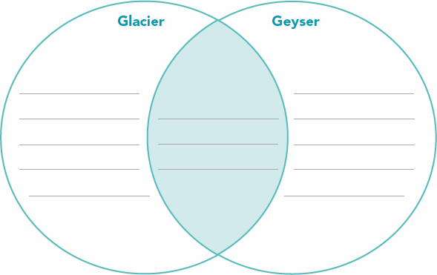
Physical and Chemical Properties of Matter
- Matter is _______________ by its _______________.
- Every form of matter has _______________ kinds of _______________- physical and chemical properties.
  - Physical properties are characteristics of a substance that can be _______________ ________________ _______________ it into _______________ _______________.
  - Chemical properties are characteristics of a substance that describe its _______________ to _______________ into _______________ _______________. To observe the _______________ _______________ of a substance you must try to change it into _______________ _______________.

Chemical and Physical Property Examples
  - A physical property of water is that it _______________ at _______________ degrees _______________. When liquid water freezes, it changes to _______________, but it is still _______________.
  - A chemical property of iron is that it combines slowly with oxygen in the air to _______________ a _______________ _______________, rust.

