What Units Are Used to Express Mass and Volume?
- What weights more… a kilogram of _______________ or a kilogram of _______________?
  - Answer: _______________.
- There are a number of different ways to _______________ matter.
- Scientists rely on _______________ and they work very hard to make sure those measurements are as _______________ as _______________.
Weight
- _______________ is a measure of the _______________ of _______________ on an _______________.
- On another planet, the _______________ of _______________ will be _______________ if the planet is _______________ _______________ than Earth and less if the planet is _______________ massive than earth.
- On the _______________ you would weigh _______________ the _______________ you do on Earth.
  - Calculate your weight on the moon ________
- To find _______________ you could _______________ an object on a _______________.
- The amount of _______________ the scale does _______________ on the _______________ of the _______________.
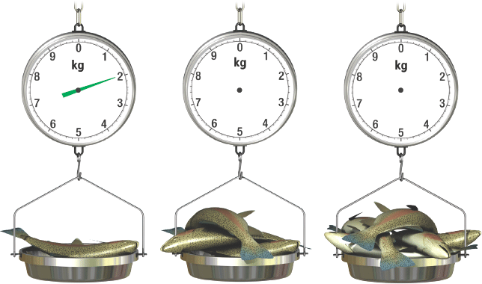
Mass
- How can you _______________ less on the _______________ than on _______________ when _______________ about you has _______________?
- Your _______________ is _______________ on the _______________ of the _______________ you are on.
- The _______________ of _______________ in an _______________ is its _______________.
  - If you travel to another _______________ the amount of _______________ that makes you up (mass) does not _______________.
  - Because of this we prefer to describe _______________ in terms of _______________ rather than _______________.
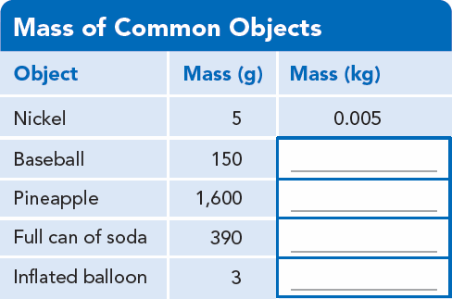
Challenge
- Suppose you are taking a flight to Europe. You are only allowed a 23-kg suitcase. How much is that in pounds? (hint 1 kg = 2.2 lbs)
- Answer = ________________
Volume
- All _______________ has _______________ and takes up _______________.
- The amount of _______________ that matter occupies is called _______________.
- The _______________ unit of volume is the _______________ _______________ (m³).
- In the lab volumes of _______________ and _______________ shaped _______________ are measured using a _______________ cylinder.

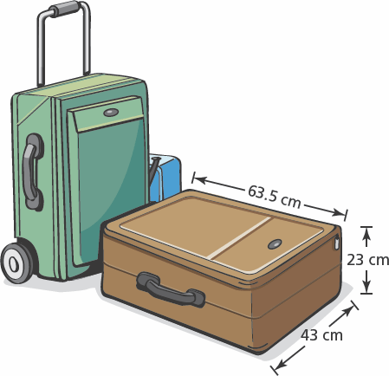
What is the volume of the suitcase? ____________________________
How is Density Determined?
- Even though a pound of _______________ weighs the same as a pound of _______________, they do not _______________ the same amount of _______________.
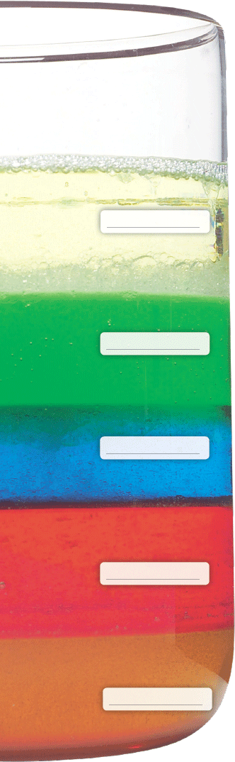
- The volumes differ because _______________ and _______________ have different _______________.
Calculating Density
- _______________ is a measure of the _______________ of a _______________ in a given _______________.
- _______________ can be expressed as the _______________ of _______________ in one _______________ _______________ (g/cm³).
- You can determine the _______________ of a sample of matter by _______________ its _______________ by its _______________.
- Density = ________________
Sinking or Floating?
- If you had a _______________ of _______________ and a _______________ of _______________ that had _______________ _______________.
- When you drop both blocks into a tub of water, you see that the wood _______________ and the iron _______________.
- The _______________ of water is _______________
- Objects with _______________ densities will _______________, and objects with _______________ densities will _______________.
- If you watch a bottle that is filled with _______________ and _______________ you will notice that the substances _______________ out.
- This happens because _______________ is _______________ _______________ than _______________.
Using Density
- Suppose you are a gold miner in the 1800’s.
- One day, while panning through the sediment in a stream, you come across a shiny golden rock.
- How do you know if it’s _______________?
- You can measure the _______________ and _______________ of the rock and find its _______________.
  - If it matches _______________, the density of gold, then you have struck it rich.

