Bridge Building Guidelines
Materials
a. Use the assorted Popsicle sticks provided by Mr. Ballien.
The sticks have the following approximate dimensions:

b. Sticks may be physically altered in the following ways:
- Cut / notched at any angle.
- Sanded to any width.
- Marked on the face for decoration using only markers, crayons and/or colored pencils.
c. Sticks may NOT be altered in the following ways:
- Soaked in any material
- No coatings of any kind, including glue, paint, cement, epoxy, etc. may be applied to any surface of the bridge.
d. Use only the Elmer’s Wood Glue given to you in class. NO hot glue allowed.

Rules for Bridge Size
Maximum horizontal length= 23 in.
Minimum horizontal length= 21 in.
Clear Span= 20 in.
Maximum height above bridge deck= 10 in.
Minimum height above bridge deck= 5 in.
Maximum width= 5 in.
Minimum Width= 4 in.
Minimum width of open roadway= 3 ½ in.
Loading Block
- Length= 5 ½ in.
- Width= 2 ½ in.
- Holes for bolts= 4 in. from center radiuses apart, ½ in. diameter for bolts
- Hook hangs about 3 in. down

Rules for Construction

- The bridge will span over a gap of 20 in between two level. Since the span is 20 in, the bridge will have to be somewhat longer to rest on the platforms.
- The bridge supports will only be able to rest on the platforms. No glue or attachments can be made to the top or sides of the test stand. No braces can be placed against the sides of the test stand or extended to the floor.
- The bridge will support a fixed load at the center of the 20 in. span. Since it is not required to support moving loads, the bridge could more properly be termed a structure. No scale path or roadway for movement across the bridge is required.
- The loading block will support a concentrated load (bucket of sand) at the center of the 20 in. span. You can support the loading block at the top, middle, or bottom of your structure. Refer to the Testing Requirements section for more information regarding the size and position of the loading block.
- Bridges will be weighed before testing
- Load will be applied until either the bridge breaks or deflects more than 2 inches. The peak load recorded will be considered the failure load.
- All bridges will be destroyed while testing
- A maximum of 50% of a craft stick’s total wide/flat surface may be glued.
- I-beams are illegal
- T-sections and longitudinal lamination may be used on the roadway only.

Testing
  - The testing load will be applied using a small loading block that has a bucket suspended below it. Dry sand will be added (by you!) to the bucket at a slow, steady rate until either an audible cracking sound together with visual evidence indicates the failure of some structural member or glue joint of the bridge.
  - The loading block will be provided by the instructor.
  - This loading block is not part of the bridge structure.
  - The loading block will be placed at the center position of the 20 in. span. It is the designer's responsibility to provide a location to support the loading block.
  - The dimensions of the loading block are approximately 5 ½ X 2 ½ X ¾ in. A chain is attached from below to the center of the plate as shown in the figure. During loading, the 5 cm edges of the loading plate will be parallel to the longitudinal axis of the bridge. The load will be applied by the means of a loading hook hanging from the eyebolt.

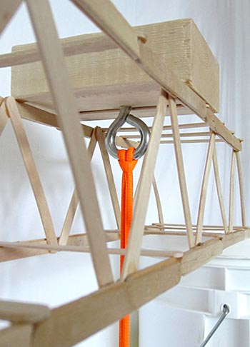

(Use this figure for as a reference, as the one we use is slightly different)

