Unit 2: Energy in the Earth System

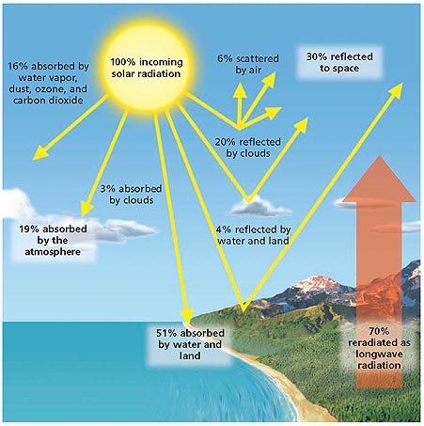
A. Earth’s Energy Budget
- The transfers of energy between Earth’s spheres can be thought of as parts of an ________________ ________________.

- _________________________________ states that energy is transferred between systems, but it cannot be created or destroyed.

- _______________________________ states that when energy transfer occurs, matter becomes _________ organized with time. Thus, the universe’s energy is spread out more uniformly over time.

- The constant exchange of _________ and energy between Earth’s spheres happens through ________________ _______________________, _________________ _____________, the radiation of energy, and the _____________ and ______________ of organisms.

B. Internal Sources of Energy (E2.2A)
- When Earth formed about ___________ billion years ago, its interior was heated by _________________ decay and ______________________ contraction.
- The decay of _____________________ atoms still generates enough ___________ to keep Earth’s interior hot. Earth’s interior also retains much of the ______________ from the planet’s formation.
- By the process of ___________________, the heat in Earth’s interior is transferred through the layers of Earth and is released at Earth’s surface.

C. External Energy Sources (E2.2A, E2.2D)
- Earth’s most important ___________________ energy source is the sun.
- _______________ radiation warms Earth’s _______________ and surface. This _________________ causes the _______________ of air masses, which generates ______________ and ocean ________________. Many chemical _______________ on Earth also require _____________ energy.
- Another important ______________ source of energy is ____________________ energy from the moon and sun. This energy helps generate __________________ that cause currents and drive the mixing of ocean _________________.

Resources and Energy- Nonrenewable Energy (B2.2B, B2.4A)

I. Nonrenewable Resources- resources that form at a rate that is much _____________________ than the rate at which they are consumed.
II. Fossil Fuels
A. General Info
- fossil fuel-a _____________________ energy resource that formed from the remains of organisms that lived long ago. Examples include ________, ____________, and ____________________
- Much of the _______________ humans use every day comes from the burning of the hydrocarbons that make up fossil fuels.
- When hydrocarbons are burned, the breaking of ________________ bonds releases energy as _____________ and light.

B. Formation of Coal
- ________________ is the most commonly burned fossil fuel, formed during a complex process called carbonization.
- Carbonization occurs when partially decomposed plant materials is buried in swamp mud and becomes ______________.
- As _______________ consume some of the peat and release the gases methane, CH4, and carbon dioxide, CO2, the contents of peat gradually change until mainly __________________ remains.
- Peat remains if conditions are not optimal for carbonization. _________________ may be used as an energy source.
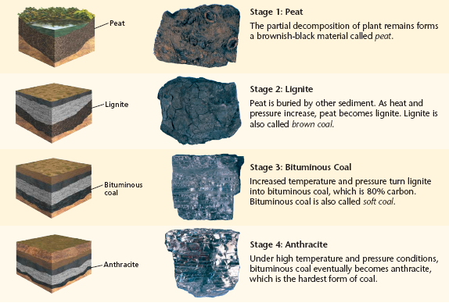

C. Types of Coal Deposits
- The partial ____________________ of plant remains forms a brownish-black material called peat.
- Peat is buried by other sediment. As ________________ and _______________ increase peat becomes lignite. Lignite is also called ______________ coal.
- Increased temperature and pressure compacts the lignite and forms ______________ coal. Bituminous coal is made of _______% carbon.
- ____________________, the hardest form of coal, is produced when ________________________ coal is under high temperatures and pressures. Anthracite coal is made of __________% carbon.

D. Formation of Petroleum and Natural Gas
- __________ and natural gas are mixtures of hydrocarbons.
- These _____________ fuels formed when heat and __________ caused chemical changes to the remains of microorganisms and plants.

E. Petroleum and Natural Gas Deposits
- Petroleum and ___________________ gas are very important sources of energy for _______________, _______________, and many other industries.
- They are mined from _________________________ sedimentary rocks.
- Petroleum accumulates beneath ______________ rock and fill the space to form an oil reservoir. Natural gas rises above petroleum, because it is less dense than both __________ and _________.

F. Oil Traps
- When a well is drilled into an _________ reservoir, the petroleum and natural gas often flow to the surface.
- After the pressure of the overlying rock is removed, fluids rise up and out through the _____________.

III. Fossil Fuel Supplies
- Fossil _____________, like minerals, are one of the main sources of energy, but are also ___________________ resources.
- Crude oil, or unrefined petroleum, is also used in the production of plastics, synthetic fabrics and rubber, medicines, waxes, chemical ____________, _____________, ________________, and many other products.
- Coal is the most __________________ fossil fuel in the world. Two-thirds of the known deposits of coal occur in the United States, _____________, and China.
- Oil ________________ is a relatively abundant material that contains petroleum. But the cost of mining oil from shale is far greater than the present cost of recovering oil from other sedimentary rocks.

IV. Nuclear Energy
A. General Info
- The ______________ that is produced from nuclear reactions is called nuclear energy.
- Scientists discovered that ___________________ had smaller fundamental parts.
- These parts could be __________________ by creating nuclear reactions with nuclear technologies.

B. Nuclear Fission
- nuclear fission-the process by which the _____________________ of a heavy atom splits into _________________ or more fragments; the process releases neutrons and energy.
- When the nucleus splits, it releases additional ________________ as well as energy.
- The newly released neutrons begin a ________________ reaction by striking nearby nuclei, which causes those nuclei to split and ________________ more neutrons and more _____________.
- If left uncontrolled, a fission reaction will escalate quickly and may result in an explosion. Controlled reactions produce heat that can be used to generate electricity.

C. How Fission Generates Electricity
- A nuclear reactor is a specialized equipment in which controlled nuclear ______________________ is carried out.
- Currently, ________________, or 235U, is the only naturally occurring element used for nuclear fission.
- This ore is mined and processed into fuel pellets with high 235U content.
- These uranium-enriched pellets are placed into rods to make ____________ rods. Bundles of these fuel rods are then bombarded by neutrons to induce a nuclear reaction.
- The resulting chain reaction from nuclear fission causes the fuel __________________ to become very hot.
- Water is ______________________ around the fuel rods to absorb and remove heat energy.
- The water is then pumped into a second circuit, where it becomes _______________ and turns the turbines that provide power for electric generators.
- A third water circuit carries away the excess _______________________ and releases it into the environment.
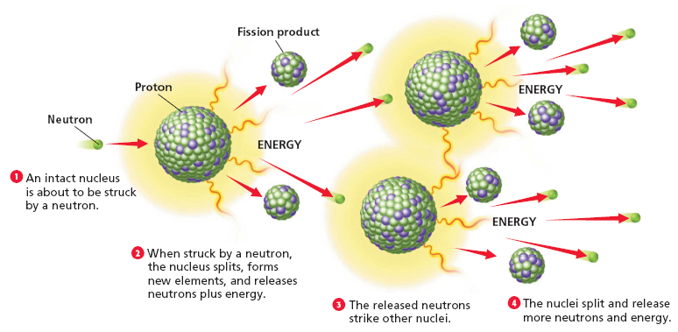

D. Advantages and Disadvantages of Nuclear Fission
- Nuclear power plants burn _________fossil fuels and produce _________ air pollution.
- However, they produce harmful ________________ materials that have very long half-lives, wastes must be stored for thousands of years.
- These waste products give off harmful doses of _______________ that can destroy plant and animal cells and can cause harmful changes in the _______________ material of living cells.

E. Nuclear Fusion
- nuclear fusion- the process by which nuclei of _____________ atoms combine to form new, more ________________ nuclei; the process releases energy
- All of the energy that ___________________ Earth from the sun is produced by nuclear fusion.
- Fusion reactions only occur at temperatures of more than _________________°C.
- The only by product of fusion are _______________ nuclei, which are _________________ to living cells.

Resources and Energy-Renewable Energy (B2.2B, B2.4A)

I. -natural resources that can be replaced at the same rate at which the resource is consumed.

II. Geothermal Energy
- -the energy produced by heat with Earth
- The resulting steam from passing by nearby magma or hot gases released by magma, deep in the earth, produces a large amount of geothermal energy.
- Engineers and scientists have harnessed geothermal energy by to reach the hot water.
- The steam and hot water are used as a source of heat and as sources of power to drive turbines, which generate .

III. Solar Energy
- solar energy- .
- Solar energy can be converted to heat energy in many different ways.
- In a , sunlight enters the house and warms the building materials, which stores some heat for the evening.
- An includes the use of solar collectors and photovoltaic cells to collect heat or convert solar energy into electricity.

IV. Energy from Biomass
- -plant material, manure, or any other organic matter that is used as an energy source.
- Biomass is a major source of energy in many countries.
- that decompose the organic matter produce gases, such as methane that can be burned.
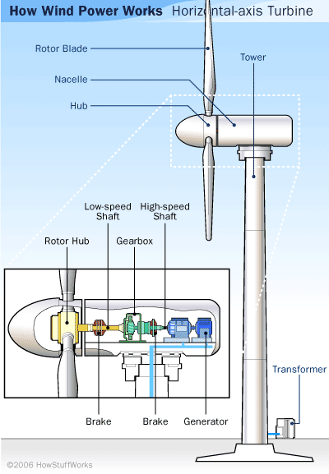
- Liquid fuels, such as , also form from the action of bacteria on biomass.
- More than half of all trees that are cut down are used as fuel for or .

V. Energy from Wind
- Wind energy is now being used to produce electricity in locations that have constant .
- may have hundreds of giant wind turbines that can produce enough energy to meet the electricity needs of entire communities.
- Wind generators are not practical everywhere. Because the wind does not always , wind energy cannot be depended on as an energy source for every location.

Wind Power in the United States

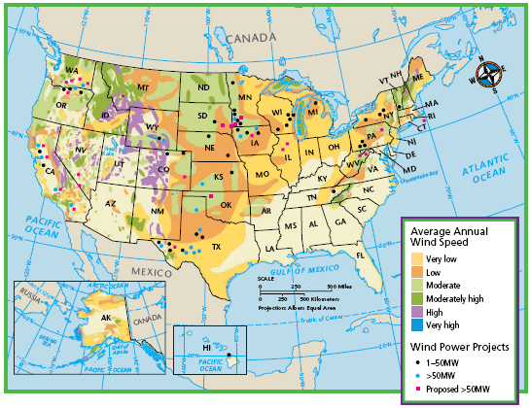
The image to the left shows the wind potential for areas found in the United States.

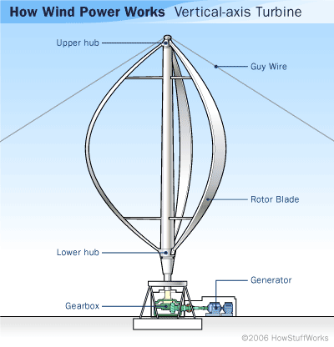
VI. Hydroelectric Energy
- hydroelectric energy- ______________________________________________________________________________________________________________________________________________________________________________________________________________________________________
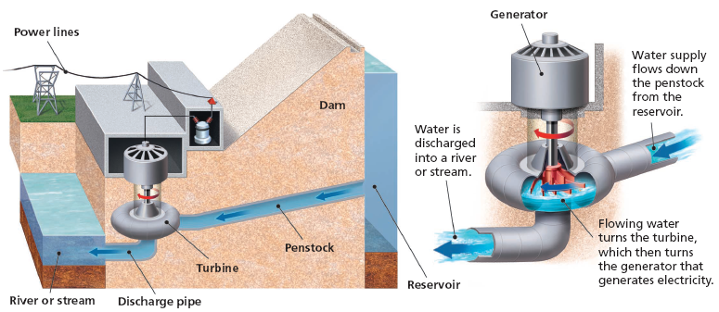
- Moving water is one of the oldest sources of . Energy can be harnessed from the running water of rivers and streams or from ocean tides or waves.
- Today, of the electricity in the United States comes from hydroelectric power plants.
- At a hydroelectric plant, massive dams hold back running water and channel the water through the plant. Inside the plant, the water spins , which turn generators to produce electricity.
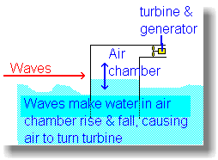
- A largely untapped future resource that is just being explored is _______________ __________________.
- _______________ ________________ is a resource that could use the world’s vast _______________ to help generate energy.
- This uses the ________________ from tides to turn turbines to create electrical energy.
- Another future energy be researched is wave energy.
- This resource uses ___________________ or buoys with magnetic coils in them or that are attached to ___________________ arms that can generate electricity when they bob on the waves.

