Unit 3: Biogeochemical Cycles (E2.3)

Cycles in the Earth’s System
A. General Info
- ______________- a group of _____________________ in which ___________ and ____________ repeatedly move through a series of reservoirs.
- _______________ - a place where _______________ or _________________ is stored.
- Many elements on Earth _____________ between reservoirs. These cycles rely on ____________ sources to drive them.
- The length of time that energy or ______________ spends in a reservoir can vary from a few _______________ to several million __________________.

B. The Nitrogen Cycle
- In the ___________________ cycle, _______________ moves from the air to ________________, from soil to __________ and ____________, and back to air again.
- Nitrogen is removed from air mainly by the action of ____________-_______________ bacteria in the soil.
- The __________________ enters plants, which are eaten by animals. The nitrogen is returned to the soil by decay and by animal wastes.
- Chemical processes that occur in the soil then release the nitrogen back into the _______________.
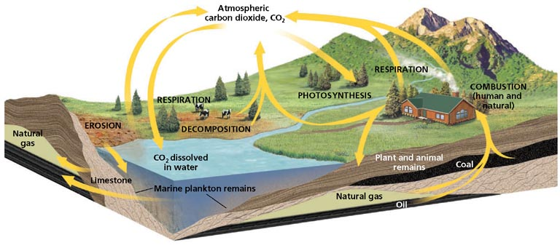

C. The Carbon Cycle (E2.3A)
- Carbon moves through all four __________________ through the carbon cycle.
- In the short-term _______________ cycle, plants convert carbon _________________, CO2, from the atmosphere into carbohydrates. When organisms’ bodies break down the ____________________ and release some of the _______________ back into the air as CO2 or through their organic wastes as CO2 or _____________ (CH4).
- In the long-term carbon cycle, carbon is stored in the __________________ in a type of rock called a ___________________.
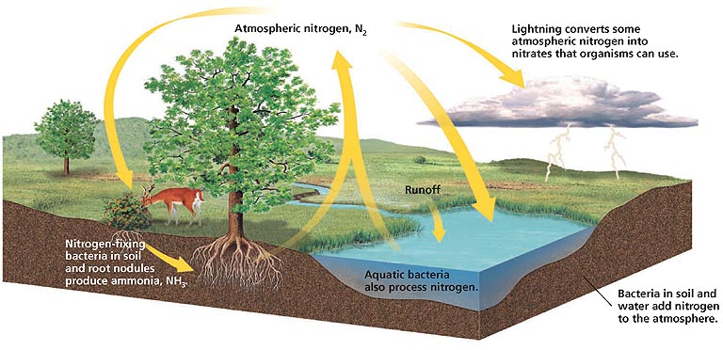

D. The Phosphorus Cycle
- During the ___________________ cycle, phosphorus moves through every _____________________ except the _______________________.
- Phosphorus enters soil and water when _______________________ breaks down, when phosphorus in rock dissolves in water, or when organisms excrete ______________________ in their waste.
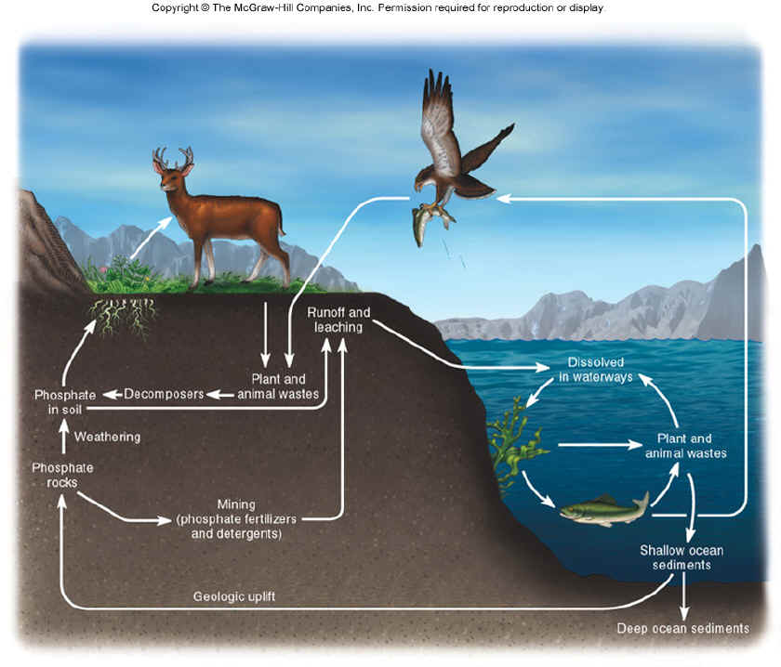
- ______________________ absorb ______________________ through their roots and incorporate the phosphorus into their _________________________.
- Animals absorb the phosphorus when they ____________________ the plants. When the animals _________, the phosphorus returns to the environment through __________________________.

E. The Water Cycle
- The movement of water from the atmosphere to Earth’s surface and back to the atmosphere is called the _________________ ________________.
- In the water cycle, water changes from ______________ water to water vapor through the energy transfers involved in ____________________ and ______________________. During these processes, water absorbs heat and changes into a _______________________ state.
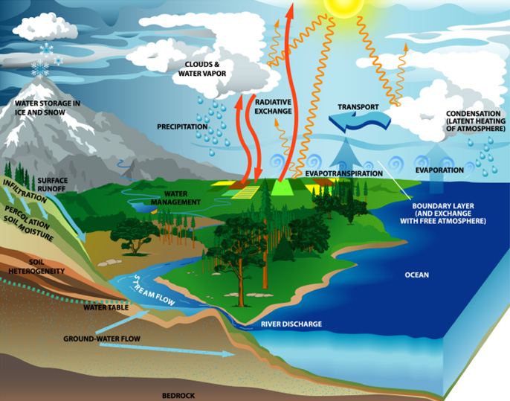
- When the water loses energy, it ________________ to form water droplets, such as those that form clouds and fall to Earth’s _____________________ as precipitation.

