Unit 5.1: Rocks-Rocks and The Rock Cycle

I. Three Major Types of Rocks
- The material that makes up the solid parts of Earth is known as _________________________.
- Based on the processes that form and change the rocks of Earth’s crust, geologists classify rocks into _________________major types by the way the rocks form.
- _________________________rock forms when magma, or molten rock, cools and hardens.
- _________________________ rock forms when sediment deposits that form when rocks, mineral crystals, and organic matter have been broken into fragments, called sediments, are compressed and cemented together.
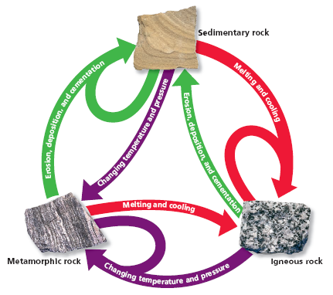
- ________________rock forms when existing rock is altered by changes in temperature, by changes in pressure, or by chemical processes.

II. The Rock Cycle
- Any of the three major types of rock can be ______________into another of the three types.
- Geologic forces and processes ______________rock to change from one type to another.
- _____________-the series of processes in which rock forms, changes from one form to another, is destroyed, and forms again by geological processes

III. Properties of Rocks
A. General info
- All rock has physical and chemical properties that are determined by how and where the rock_______________.
- The rate at which rock ______________________and the way that rock breaks apart are determined by the chemical stability of the minerals in the rock.
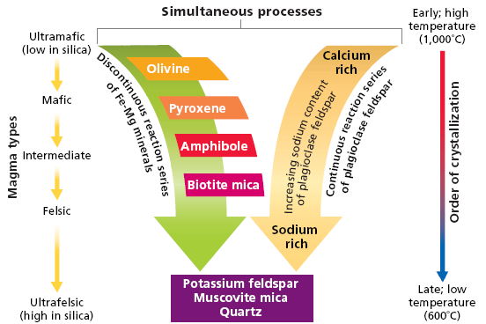
B. Bowen’s Reaction Series
- ______________’s reaction series-the simplified pattern that illustrates the order in which minerals crystallize from cooling magma according to their chemical composition and melting point

- The pattern of mineral formation from __________depends on the chemical composition of the magma.

C. Chemical Stability of Minerals
- The rate at which mineral chemically breaks down is dependent on the _________________stability of the mineral.
- Chemical stability is a measure of the tendency of a chemical compound to __________________its original chemical composition rather than break down to form a different chemical.
- The chemical stability of minerals is dependent on the _______________of the chemical bonds between atoms in the mineral.

D. Physical Stability of Rocks
- Rocks have natural zones of _________________that are determined by how and where the rocks form.
- When rock that formed under intense ____________________is uplifted to Earth’s surface, decreased pressure allows the joints or fractures to open.
- Once these ________________are exposed to air and water, the processes of chemical and mechanical weathering begin

