Unit 5.2: Rocks-Igneous Rock

I. The Formation of Magma
A. General Info
- ___________________rock-rock that forms when magma cools and solidifies
- The three factors that affect whether rock melts include______________, pressure, and the presence of fluids in the rock.
- Rock melts when the temperature of the rock ______________to above the melting point of minerals in the rock.
- Rock melts when excess pressure is ___________________from rock that is hotter than its melting point.
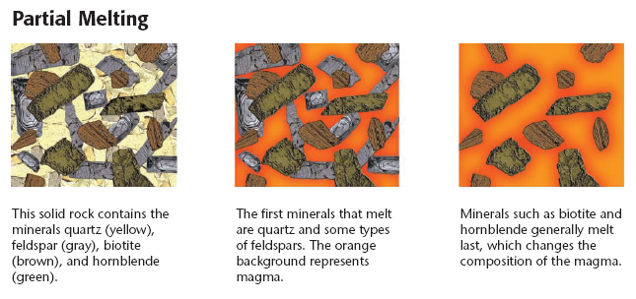
- Rock may melt when fluids, such as____________, are added. The addition of fluids generally decreases the melting point of certain minerals in the rock.

B. Partial Melting
- Different minerals have different melting points, and minerals that have _____________melting points are the first minerals to melt.
- As the temperature increases and as other minerals melt, the magma’s ____________________changes.
- The process in which different minerals in rock melt at different temperatures is called_________________.

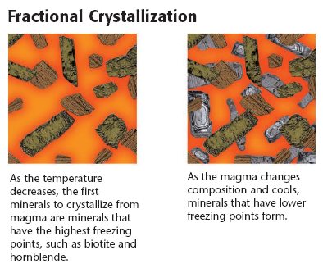

C. Fractional Crystallization
- When magma cools, the cooling process is the _______________of the process of partial melting.

- Chemicals in magma combine to form minerals, and each mineral has a different __________ point. Minerals that have the highest freezing points crystallize first.

- The crystallization and removal of different minerals from the cooling magma is called _________________crystallization.

II. Textures of igneous Rocks
A. General Info
- Igneous rocks are classified according to where magma cools and__________________________.
- _______________igneous rock-rock formed from the cooling and solidification of magma beneath Earth’s surface
- _______________ igneous rock-rock formed from the cooling and solidification of lava at Earth’s surface
- The ___________________ of igneous rock is determined by the size of the crystals in the rock. The size of the crystals in determined mainly by the cooling rate of the magma.

B. Coarse-Grained Igneous Rock
- Because intrusive igneous rocks cool slowly, they commonly have _________________mineral crystals.
- Igneous rocks that are composed of large, well-developed mineral grains are described as having a ________________________________texture.

C. Fine-Grained Igneous Rock
- Because extrusive igneous rocks cool rapidly, they are commonly composed of small ________________grains.
- Igneous rocks that are composed of small crystals are described as having a ______________-grained texture.

D. Other Igneous Rock Textures
- When magma cools slowly at first, but then cools more rapidly as the magma nears or reaches Earth’s surface, the igneous rock that forms may have large crystals embedded within a mass of smaller crystals. This texture is called ____________________ texture.
- When highly viscous magma cools very rapidly, few crystals will grow. When the magma contains a small amount of dissolved gases, a ___________________texture will result. When the magma contains a large percentage of dissolved gases, the gases are trapped as bubbles in the rock, and a __________________________ texture will result.

III. The Composition of Igneous Rock
- The mineral composition of an igneous rock is determined by the chemical composition of the ________________from which the rock formed.

A. Felsic Rock
- ______________-describes magma or igneous rock that is rich in feldspars and silica and that is generally light in color
- Common minerals in felsic rocks include potassium feldspar and quartz.
- The felsic family includes many common rocks, such as______________________, rhyolite, obsidian, and pumice.

B. Mafic Rock
- _____________-describes magma or igneous rock that is rich in magnesium and iron and that is generally dark in color
- Common minerals in mafic rocks include plagioclase feldspar and___________________.
- The mafic family includes the common rocks basalt and______________________.

C. Intermediate Rocks
- Rocks in the ________________________family contain lower proportions of silica than rocks in the felsic family do but contain higher proportions of silica than rocks in the mafic family do.
- Rocks in the intermediate family include_____________________ and andesite.

IV. Intrusive Igneous Rock Structures
A. Batholiths and Stocks
- __________________are intrusive formations that spread over at least 100 km² when they are exposed on Earth’s surface.
- Stocks are similar to batholiths but cover less than _____________ km² at the surface.

B. Laccoliths
- A laccolith is an intrusive formation that forms when magma flows between rock layers and pushes the overlying rock layers into a ______________________.

C. Sills and Dikes
- When magma flows between layers of rock and hardens to form a body of rock that is parallel to the layers of rock that surround it, a ___________________forms.
- When magma forces its way through rock layers by following existing fractures or by creating new fractures, a _______________ forms. Dikes cut across layers rather than lying parallel to the rock layers.
- Sills and __________________vary in thickness from a few centimeters to hundreds of meters.

V. Extrusive Igneous Rock Structures
- Igneous rock masses that form on Earth’s surface are called ________________________.
- A _____________________________is a vent through which magma, gases, or volcanic ash is expelled. Volcanic cones and volcanic necks are common examples of extrusive igneous structures.
- Lava flows, lava plateaus, and tuff layers are other common extrusions.

