Unit 5.3: Rocks-Sedimentary Rock

I. Formation and Classification of Sedimentary Rocks
A. Formation
- Most sedimentary rock is made up of ________________________of different types of sediment, which is loose fragments of rock, minerals, and organic materials.
- Two main processes convert loose sediment into ___________________rock—compaction and cementation.
→ _____________-the process in which the volume and porosity of a sediment is decreased by the weight of overlying
sediments as a result of burial beneath other sediments

→ ____________-the process in which minerals precipitate into pore spaces between sediment grains and bind sediments
together to form rock
B. Classification
- Geologists classify sedimentary rocks by the ___________by which the rocks form and by the composition of the rocks.
- There are ______ main classes of sedimentary rocks-chemical, organic, and clastic.
- These three classes contain their own classifications of rocks that are __________ based on the shape, size, and composition of the sediments that form the rocks.

II. Chemical Sedimentary Rock
- chemical sedimentary rock-sedimentary rock that forms when minerals precipitate from a __________or settle from a suspension
- Some chemical sedimentary rock forms when dissolved minerals _____________ out of water because of changing concentrations of chemicals.
- When water evaporates, the minerals that were dissolved in the water are left behind. Eventually, the concentration of minerals in the remaining water becomes high enough to cause _______________ to precipitate out of the water.
- Rocks that form through evaporation are called ________________. Gypsum and halite are common evaporites.

III. Organic Sedimentary Rocks
- organic sedimentary rock-sedimentary rock that forms from the remains of _______________ or animals
- Coal and some limestones are examples of _______________ rocks.
- Organic limestones form when ____________organisms, such as coral, clams, oysters, and plankton, remove the chemical components of the minerals calcite and aragonite from sea water.
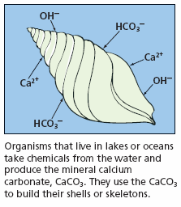
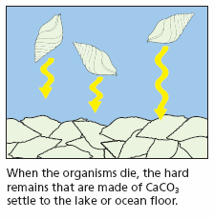
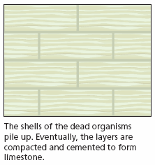
- The organisms make their shells from these minerals, and when the organisms die, their shells settle to the bottom of the ocean, accumulate, and are compacted to form _________________.

IV. Clastic Sedimentary Rock
- clastic sedimentary rock-sedimentary rock that forms when fragments of ________________rocks are compacted and cemented together
- Clastic sedimentary rocks are classified by the______________ of the sediments they contain.
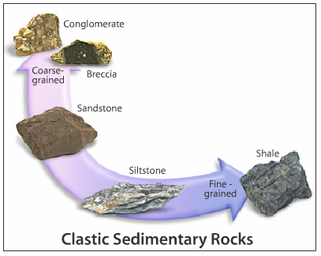
Rock Name | Sediment Size Contained
conglomerate | large, rounded pieces
breccia | large, angular pieces
sandstone | composed of sand-sized grains
shale | composed of clay-sized particles

V. Characteristics of Clastic Sediments
A. General Info
- The physical characteristics of sediments are determined mainly by the way sediments were _____________ to the place where they are deposited.
- Sediments are transported by ____________ main agents: water, ice, wind, and the effects of gravity.
- The ______________ with which the agent of erosion moves affects the size of sediment particles that can be carried and the distance that the particles will move.
- In general, both the _________________the sediment is moved and the agent that moves the sediment determine the characteristics of that sediment.

B. Sorting
- The tendency for currents of air or water to separate sediments according to size is called _________________.
- In well-sorted sediments, all of the grains are roughly the same size and shape. _____________sorted sediment consists of grains that are many different sizes.
- The sorting of a sediment is the result of changes in the speed of the agent that is moving the sediment. ____________-moving currents can carry larger particles than slower-moving currents can.

C. Angularity
- As sediment is transported from its source to where it is deposited, the particles collide with each other and with other objects in their path. These ____________________cause the particles to change size and shape.
- When particles first __________________ from the source rock, they tend to be angular and uneven.
- Particles that have moved long distances from the source tend to be more _______________ and smooth.
- In general, the farther sediment travels from its source, the ______________ and smoother the particles of sediment become.

VI. Sedimentary Rock Features
A. General Info
- The setting in which sediment is deposited is called a ___________________environment.
- Each depositional environment has different characteristics that create specific structures in sedimentary rock. These features allow scientists to___________________ the depositional environment in which the rock formed.

B. Stratification
- Layering of sedimentary rock is called __________________. Stratified layers, also called beds, vary in thickness and composition.
- Stratification occurs when the____________________ of sediment deposition change.

C. Cross-Beds and Graded Bedding
- Cross-beds, or slanting layers within rock strata, commonly form in sand _______________ or river beds.
- Graded bedding is a feature in which various sizes and kinds of materials are deposited in one layer, with the largest grains at the bottom and ____________________ grains at the top.

D. Ripple Marks
- ____________________marks form when air or water flows over sand to form ripples, and the ripples are preserved in the rock. Ripple marks commonly form in sediment at the beach or on a river bed.

E. Mud Cracks
- Mud cracks form when muddy deposits dry and shrink. The __________________ causes the drying mud to crack.
- Mud cracks form on river floodplains or on dry lake beds.

F. Fossils and Concretions
- ______________________are the remains of organisms that are preserved in rock.
- Concretions are lumps of minerals that precipitate from fluids and build up around a nucleus or in a cavity in existing rock.

