Unit 5.4: Rocks-Metamorphic Rock

I. Formation of Metamorphic Rocks
A. General Info
- ____________________-the process in which one type of rock changes into metamorphic rock because of chemical processes or changes in temperature and pressure.
- During metamorphism, heat, pressure, and hot fluids cause some ______________to change into other minerals.
- Minerals may also change in size or shape, or they may separate into _________________bands that give the rock a layered appearance.
- Hot fluids may circulate through the rock and change the mineral composition of the rock by ___________________ some materials and by adding others.
- The type of rock that forms because of metamorphism can indicate the ___________ under which the original rock changed.
- The composition of the rock being metamorphosed, the amount and direction of _______________, and the presence or absence of certain fluids cause different combinations of minerals to form.
- Two types of metamorphism occur in Earth’s crust-contact metamorphism and _________________ metamorphism.

B. Contact Metamorphism
- _______________ metamorphism-a change in the texture, structure, or chemical composition of a rock due to contact with magma

C. Regional Metamorphism
- _____________ metamorphism-a change in the texture, structure, or chemical composition of a rock due to changes in temperature and pressure over a large area, generally are a result of tectonic forces
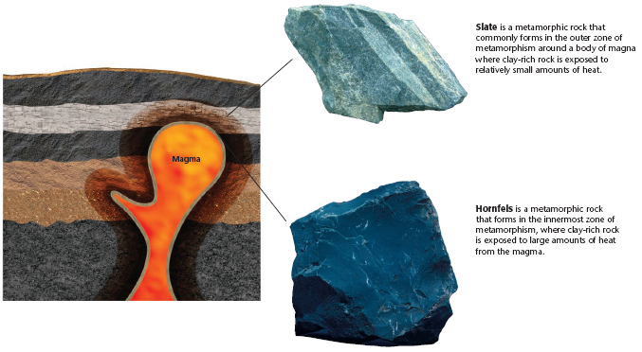

II. Classification of Metamorphic Rocks
A. Foliated Rocks
- _________________-the metamorphic rock texture in which minerals grains are arranged in planes or bands.
- Extreme pressure may cause the mineral crystals in the rock to realign or ______________to form parallel bands.
- Foliation also occurs as minerals that have different compositions separate to produce a series of alternating dark and light bands.
- Foliated metamorphic rocks include the common rocks slate, ___________________, and gneiss.
B. Nonfoliated Rocks
- _________________-the metamorphic rock texture in which minerals grains are not arranged in planes or bands.
- Many nonfoliated metamorphic rocks contain grains of only one mineral or contain very small amounts of other minerals. Thus, the rock ____________________form bands of different minerals.
- Other nonfoliated metamorphic rocks contain grains that are round or square. These grains are unlikely to change shape or position when_____________________ to directed pressure.
- Nonfoliated metamorphic rocks include the common rocks _____________________ and quartzite.

