Unit 6.1: Plate Tectonics – Continental Drift

- _______________ Hypothesis
  - _______________ _______________-the hypothesis that states that the continents once formed a single _______________, _______________ _______________, and _______________ to their _______________ location.
  - The _______________ of continental drift was first proposed by _______________ scientist Alfred _______________ in 1912.
  - Wegener used several different types of _______________ to support his hypothesis.
- Wegener’s _______________ – these things provided evidence that the continents were once _______________.
  - _______________ _______________ (2 types):
    - _______________: a hippo like fossil found on 3 continents far apart. This animal “_______________” by walking along the bottom of areas of _______________ water, but because this animal _______________ to breathe oxygen it had to be able to get to the surface to breathe, so it couldn’t cross very deep bodies of _______________ such as those that separated the 3 continents if was found on.
    - _______________: a tropical _______________-_______________ fossil found on 5 continents- it backed up continental drift in 2 ways:
      - It was a _______________ _______________ found on _______________ – so that continent must’ve been somewhere _______________ once.
      - The fern _______________ using a kind of spore that was to heavy to blow long _______________, and that would have become _______________ and rotted if it floated in the ocean water to long. It also was found on 3 different continents _______________ far apart.
  - Evidence from _______________ _______________: ages and types of _______________ in the coastal regions of widely separated areas _______________ _______________- if the rock patterns in mountain chains on 2 different _______________ match, they must have originally been all part of one _______________ chain b/c it is impossible for 2 areas to have the exact same conditions to _______________ _______________ patterns _______________.
  - _______________ _______________: changes in climatic patterns suggested the continents had not always been located where they are now-fossils of _______________ _______________ were found on land masses that were currently in _______________ regions, so the land masses must have been located in a more _______________ region at _______________ point in time.
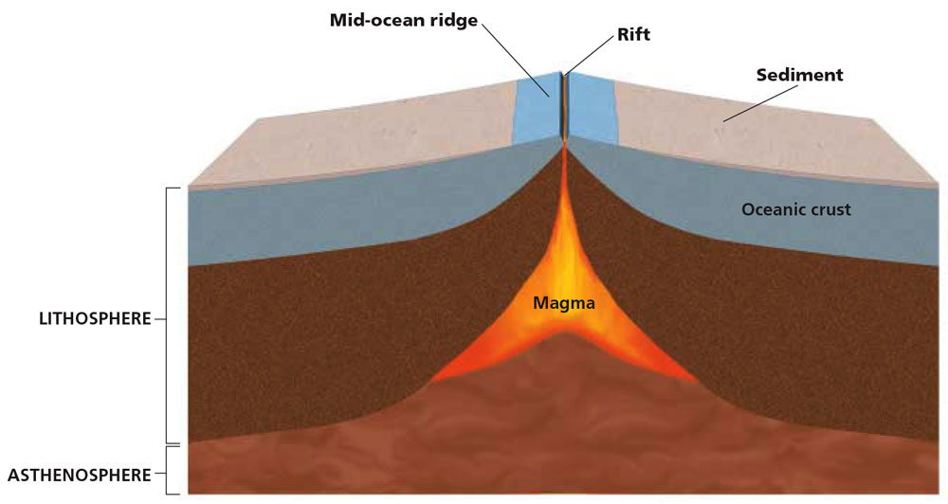
- Missing _______________
  - Wegener proposed that the continents moved by _______________ through the rock of the ocean _______________.
  - Wegener’s ideas were strongly _______________.
  - Wegener’s mechanism was disproved by _______________ _______________.
  - Wegener spent the _______________ of his life searching for a _______________ for the movement of continents.
Figure 1: A Mid-Ocean Ridge

→ Rocks closer to a mid-ocean ridge are younger than rocks farther from the ridge.

→ Rocks closer to the
ridge are covered with less sediment than rocks farther from the ridge.

- Mid-Ocean _______________
  - _______________-_______________ _______________-a long, undersea mountain chain that has a _______________, _______________ _______________ at its center, that forms as magma rises from the _______________, and that creates new oceanic _______________ (sea floor) as _______________ _______________ move apart.
  - In 1947, a group of scientists set out to _______________ the _______________-_______________ _______________. While studying the Mid-Atlantic Ridge, scientists noticed two surprising trends:
    - The sediment that covers the sea floor is _______________ closer to a _______________ than it is farther from the ridge
    - The ocean floor is _______________ _______________. Rocks on land are as old as 3.8 billion years. _______________ of the oceanic rocks are more than 190 million years old.
- Sea-Floor _______________
  - Sea-floor spreading-the process by which new _______________ _______________ (sea floor) forms as _______________ rises to Earth’s surface and solidifies at a mid-ocean ridge
  - _______________-the study of the alignment of magnetic minerals in rock, specifically as it relates to the _______________ of Earth’s magnetic poles; also the magnetic properties that rock acquires during formation
  - In the late 1950’s geologist _______________ _______________ proposed that the valley at the center of the mid-ocean ridge was a _______________, or _______________, in Earth’s crust.
  - As the ocean floor moves away from the ridge, _______________ rock, or magma, rises to _______________ the crack.
  - Hess suggested that if the sea floor is _______________, the continents might be _______________ also.
  - He suggested this might be the _______________ that _______________ was searching for.

Figure 2: Sea-Floor Spreading
As the ocean floor spreads apart, magma rises to fill the rift and then cools to form new rock.
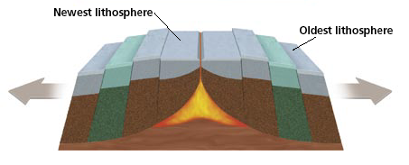
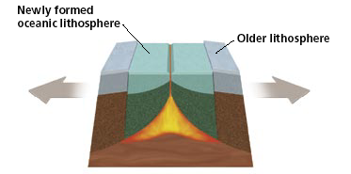
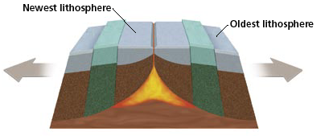

Step 1 Step 2 Step 3

- Paleomagnetism
  - _______________ Info
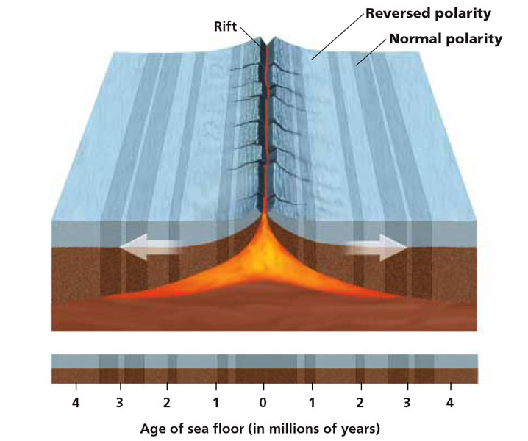
    - _______________-the study of the _______________ of _______________ _______________ in rock, specifically as it relates to the reversal of Earth’s magnetic poles; also the magnetic properties that rock _______________ _______________ _______________
    - As magma _______________ to form rock, _______________-_______________ minerals in the magma align with Earth’s magnetic field. When the rock hardens, the _______________ _______________ of the minerals becomes _______________.
  - Magnetic _______________
Figure 3: Magnetic Symmetry

→ The pattern of magnetic symmetry and age of rock formation indicate that new rock forms at the center of a ridge and then move away from the center in opposite directions.

    - Scientists have _______________ rocks whose magnetic orientations point _______________ of Earth’s current magnetic field.
    - Rocks with magnetic fields that point _______________ (normal polarity) are all classified in the _______________ _______________ _______________.
    - Rocks with magnetic fields that point _______________ (reversed polarity) also all _______________ _______________ _______________ _______________ _______________.
    - When scientists placed these periods of _______________ and _______________ polarity in chronological order, they discovered a pattern of _______________ _______________ and _______________ polarity
    - Scientists used this pattern to create the _______________ reversal _______________ _______________.
  - Magnetic _______________
    - Scientists discovered a _______________ magnetic pattern on the ocean floor on each side of a _______________-_______________ _______________.
    - The pattern on one side of the ridge is a _______________ image of the _______________ on the other side.
    - When drawn on a map, these patterns match the _______________ reversal time scale.
- Wegener _______________
  - Reversal patterns on the sea floor could also be _______________ _______________ _______________. The reversals in land rocks also matched the _______________ reversal time scale.
  - Because the same _______________ appears in rocks of the same ages on both land and the sea floor, _______________ agreed that the _______________ patterns showed change over time.
  - The idea of _______________-_______________ spreading provides a way for the _______________ to move over the Earth’s _______________.
  - Sea-floor _______________ was the mechanism that verified Wegener’s _______________ of continental _______________.

