Unit 6.2: Plate Tectonics – The Theory of Plate Tectonics

I. How _______________ Move
- _______________ _______________-the theory that explains how large pieces of the _______________, called _______________, move and _______________ shape.
- _______________-the solid, outer layer of Earth that consists of the _______________ and the _______________ _______________ part of the _______________.
- _______________- the solid, _______________ layer of the mantle beneath the _______________; made of _______________ rock that _______________ very slowly, which _______________ tectonic plates to _______________ on top of it.
- The _______________ forms the _______________ outer shell of Earth and is _______________ into _______________ blocks or _______________ _______________.
- The tectonic plates ride on the _______________ in much the same way that blocks of wood _______________ _______________ _______________.
- Tectonic plates can include _______________ _______________, _______________ _______________, or _______________.
- Continents and oceans are _______________ along on the moving _______________ plates in the same way _______________ are carried by a _______________.

II. _______________ Plates
- Scientists have identified about _______________ _______________ _______________ plates.
- Scientists identify plate _______________ primarily by studying data from _______________.
- The locations of _______________ can also help identify the _______________ of plate boundaries.
- The boundaries of _______________ plates do not always match the _______________ of _______________.
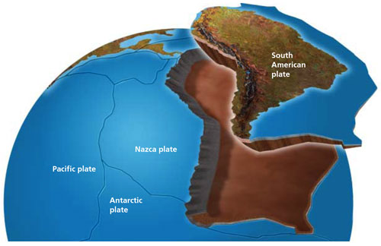
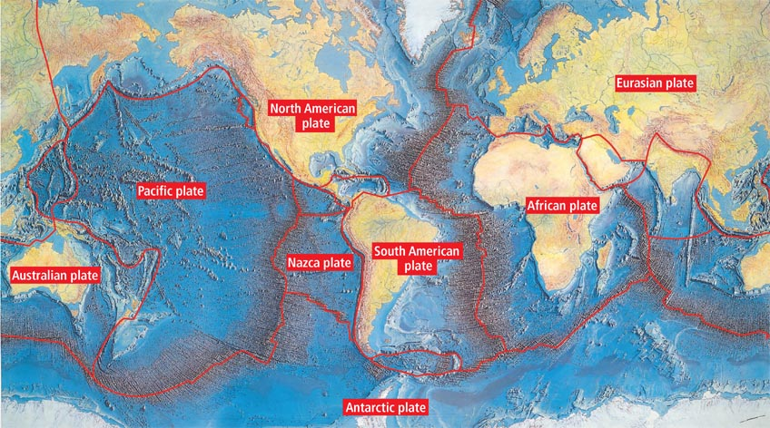

Figure 1:
Tectonic Plate riding on the aesthenosphere

Figure 2: Earth’s major Tectonic Plates

III. Causes of Plate _______________
A. General Info
- Many scientists think that the _______________ of tectonic plates is partly due to _______________.
- _______________-is the movement of heated _______________ due to differences in _______________ that are caused by differences in _______________.
- The convection process can be modeled by _______________ _______________ in a pot on the stove. As the water at the _______________ of the pot is _______________, the water at the bottom _______________ and becomes _______________ _______________ than the _______________ water above it.
- The _______________, _______________ water _______________, and the _______________ _______________ _______________ to the surface to create a cycle called a _______________ _______________.

B. Mantle _______________
- Scientists think that tectonic plates are part of a _______________ _______________.
- _______________ generated by Earth’s _______________ and _______________ within the mantle heat the mantle. This heated material rises through the _______________, _______________ material around it.
- As the hot material _______________, the cooler, _______________ material flows _______________ from the hot material and sinks into the mantle to replace the _______________ _______________.
- As the mantle material _______________, it drags the _______________ _______________ _______________ along with it.

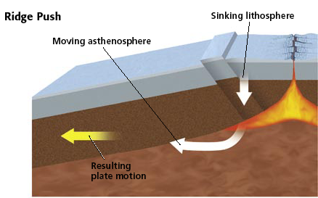
C. _______________ Push
- As the cooling rock sinks, the _______________ below it exerts force on the rest of the plate called _______________ _______________. This force _______________ the rest of the plate _______________ from the _______________-_______________ _______________.

D. _______________ Pull
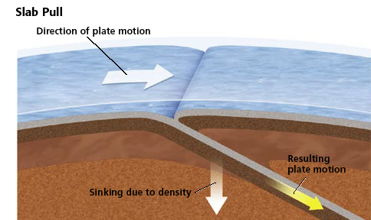
- When the leading edge of a plate near a _______________-_______________ _______________ cools it becomes _______________ and eventually begins to _______________ back into the _______________. As this leading edge is _______________ (sinking), it pulls the rest of the plate behind it downward into the mantle exerting a force called _______________ _______________.

IV. _______________ of Plate Boundaries
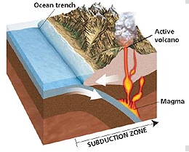
    - General Info
      - _______________ _______________ boundaries may be in the _______________ of the ocean floor, around the _______________ _______________ _______________, or even _______________ _______________, and each plate boundary is associated with a _______________ type of _______________ activity.
      - The plates move about _______________-_______________ _______________/_______________ and where they meet one of three types of boundaries or margins are formed: _______________ _______________, _______________ _______________ & _______________/_______________ _______________.
    - _______________ Margins- occur when plates move toward each other. At the plate boundaries, they may produce 2 types of _______________:
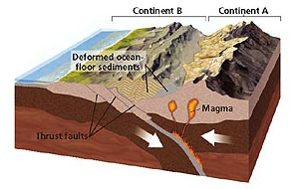
      - Type 1: _______________ _______________ - one plate may be forced under the other into the mantle and old crust is destroyed as it is recycled into the mantle. As the _______________ plate is forced back into the mantle, it often _______________ and finds its way back up to the _______________ through cracks in the crust, causing _______________ to form.
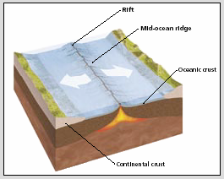
      - Type 2: _______________/_______________ _______________- both plates may be forced _______________ causing _______________ at _______________ points in the _______________ somewhere behind the boundaries. As the crust crumples and is forced upwards it often forms _______________.
Convergent Margin: Subduction Zone
    - Divergent _______________- when plates move away from each other & form a _______________ _______________ where magma escapes from the mantle and forms new crust. _______________ are also often found at these boundaries where _______________ _______________ the mantle.
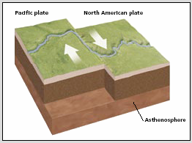
    - _______________/_______________ _______________- when plates simply _______________ _______________ each other, no crust is _______________ _______________ _______________ at these boundaries. These margins form fracture/fault zones where _______________ often occur due to the _______________ that builds up along the _______________.
Divergent Margin: Spreading Zone
Transform/Lateral Margin: Fracture/Fault Zone

