Unit 6.3: Plate Tectonics-The Changing Continents

I. _______________ Earth’s Crust
A. Rifting and Continental _______________
- _______________- the process by which Earth’s crust breaks apart; can occur within _______________ crust or _______________ crust
- Slow movements of _______________ _______________ change the size and shape of the continents over millions of years.
- All of the continents that _______________ today contain large areas of stable rock, called _______________, that are older than 540 million years. Rocks within the _______________ that have been exposed at Earth’s surface are called _______________.
- One way that continents change _______________ is by _______________ _______________. Rifting is the process by which a continent breaks apart.

B. _______________ and _______________ Growth
- _______________-a piece of lithosphere that has a unique geologic history and that may be part of a larger piece of _______________, such as a _______________
- Continents change not only by _______________ apart but also by gaining material. Most continents consist of _______________ surrounded by a patchwork of _______________.
- Terranes become part of a continent at _______________ _______________. When a tectonic plate carrying a terrane _______________ under a plate made of continental lithosphere, the terrane is scraped off of the subducting plate and becomes part of the _______________.

II. Effects of _______________ Change
- Modern climates are a result of past _______________ of tectonic plates. When continents move, the _______________ of air and _______________ around the globe changes and causes climates to change.
- _______________ evidence shows that ice once covered most of Earth’s continental _______________. As continents began to drift around the _______________, however, global temperatures changed and much of the _______________ _______________ melted.
- As continents rift or as mountains form, _______________ of organisms are separated. When populations are separated, new species may _______________.

III. The _______________ Cycle
A. General Info
- _______________ _______________-the process where supercontinents form & _______________ _______________ over millions of years
- _______________-the supercontinent that formed 300 million years ago and that began to _______________ _______________ beginning 200 million years ago
- _______________-the single, large _______________ that covered Earth’s surface during the time the supercontinent Pangaea existed

B. Why Supercontinents _______________
- Several times in the past, the continents were _______________ into large landmasses called _______________.
- Supercontinents broke apart to form _______________ continents that moved around the globe. Eventually, the smaller continents joined again to _______________ another supercontinent.
- The movement of plates toward convergent boundaries causes continents to _______________.
- Because neither continent _______________ beneath the other, the plate boundary becomes inactive, and a new _______________ boundary forms.
- Over time, all of the continents _______________ to form a _______________.
- Then, heat from Earth’s interior builds up under the supercontinent, and _______________ form in the _______________. The supercontinent breaks apart, and plates carrying separate continents _______________ around the _______________.

C. _______________ of Pangaea  - The _______________ Pangaea formed about 300 million years ago.  - Several _______________ ranges, such as the _______________ _______________ and the _______________ _______________ formed during the collisions that created Pangaea.  - A body of water called the _______________ _______________ cut into the eastern edge of Pangaea.  - The single, large ocean that surrounded Pangaea was called _______________.  D. _______________ of Pangaea  - About 200 million years ago (during the Mesozoic Era), Pangaea began to break into two continents-_______________ and _______________.  - _______________ became the continents of _______________ _______________ and _______________.  - _______________ became the continents of _______________, _______________ _______________, _______________, _______________, and _______________. | 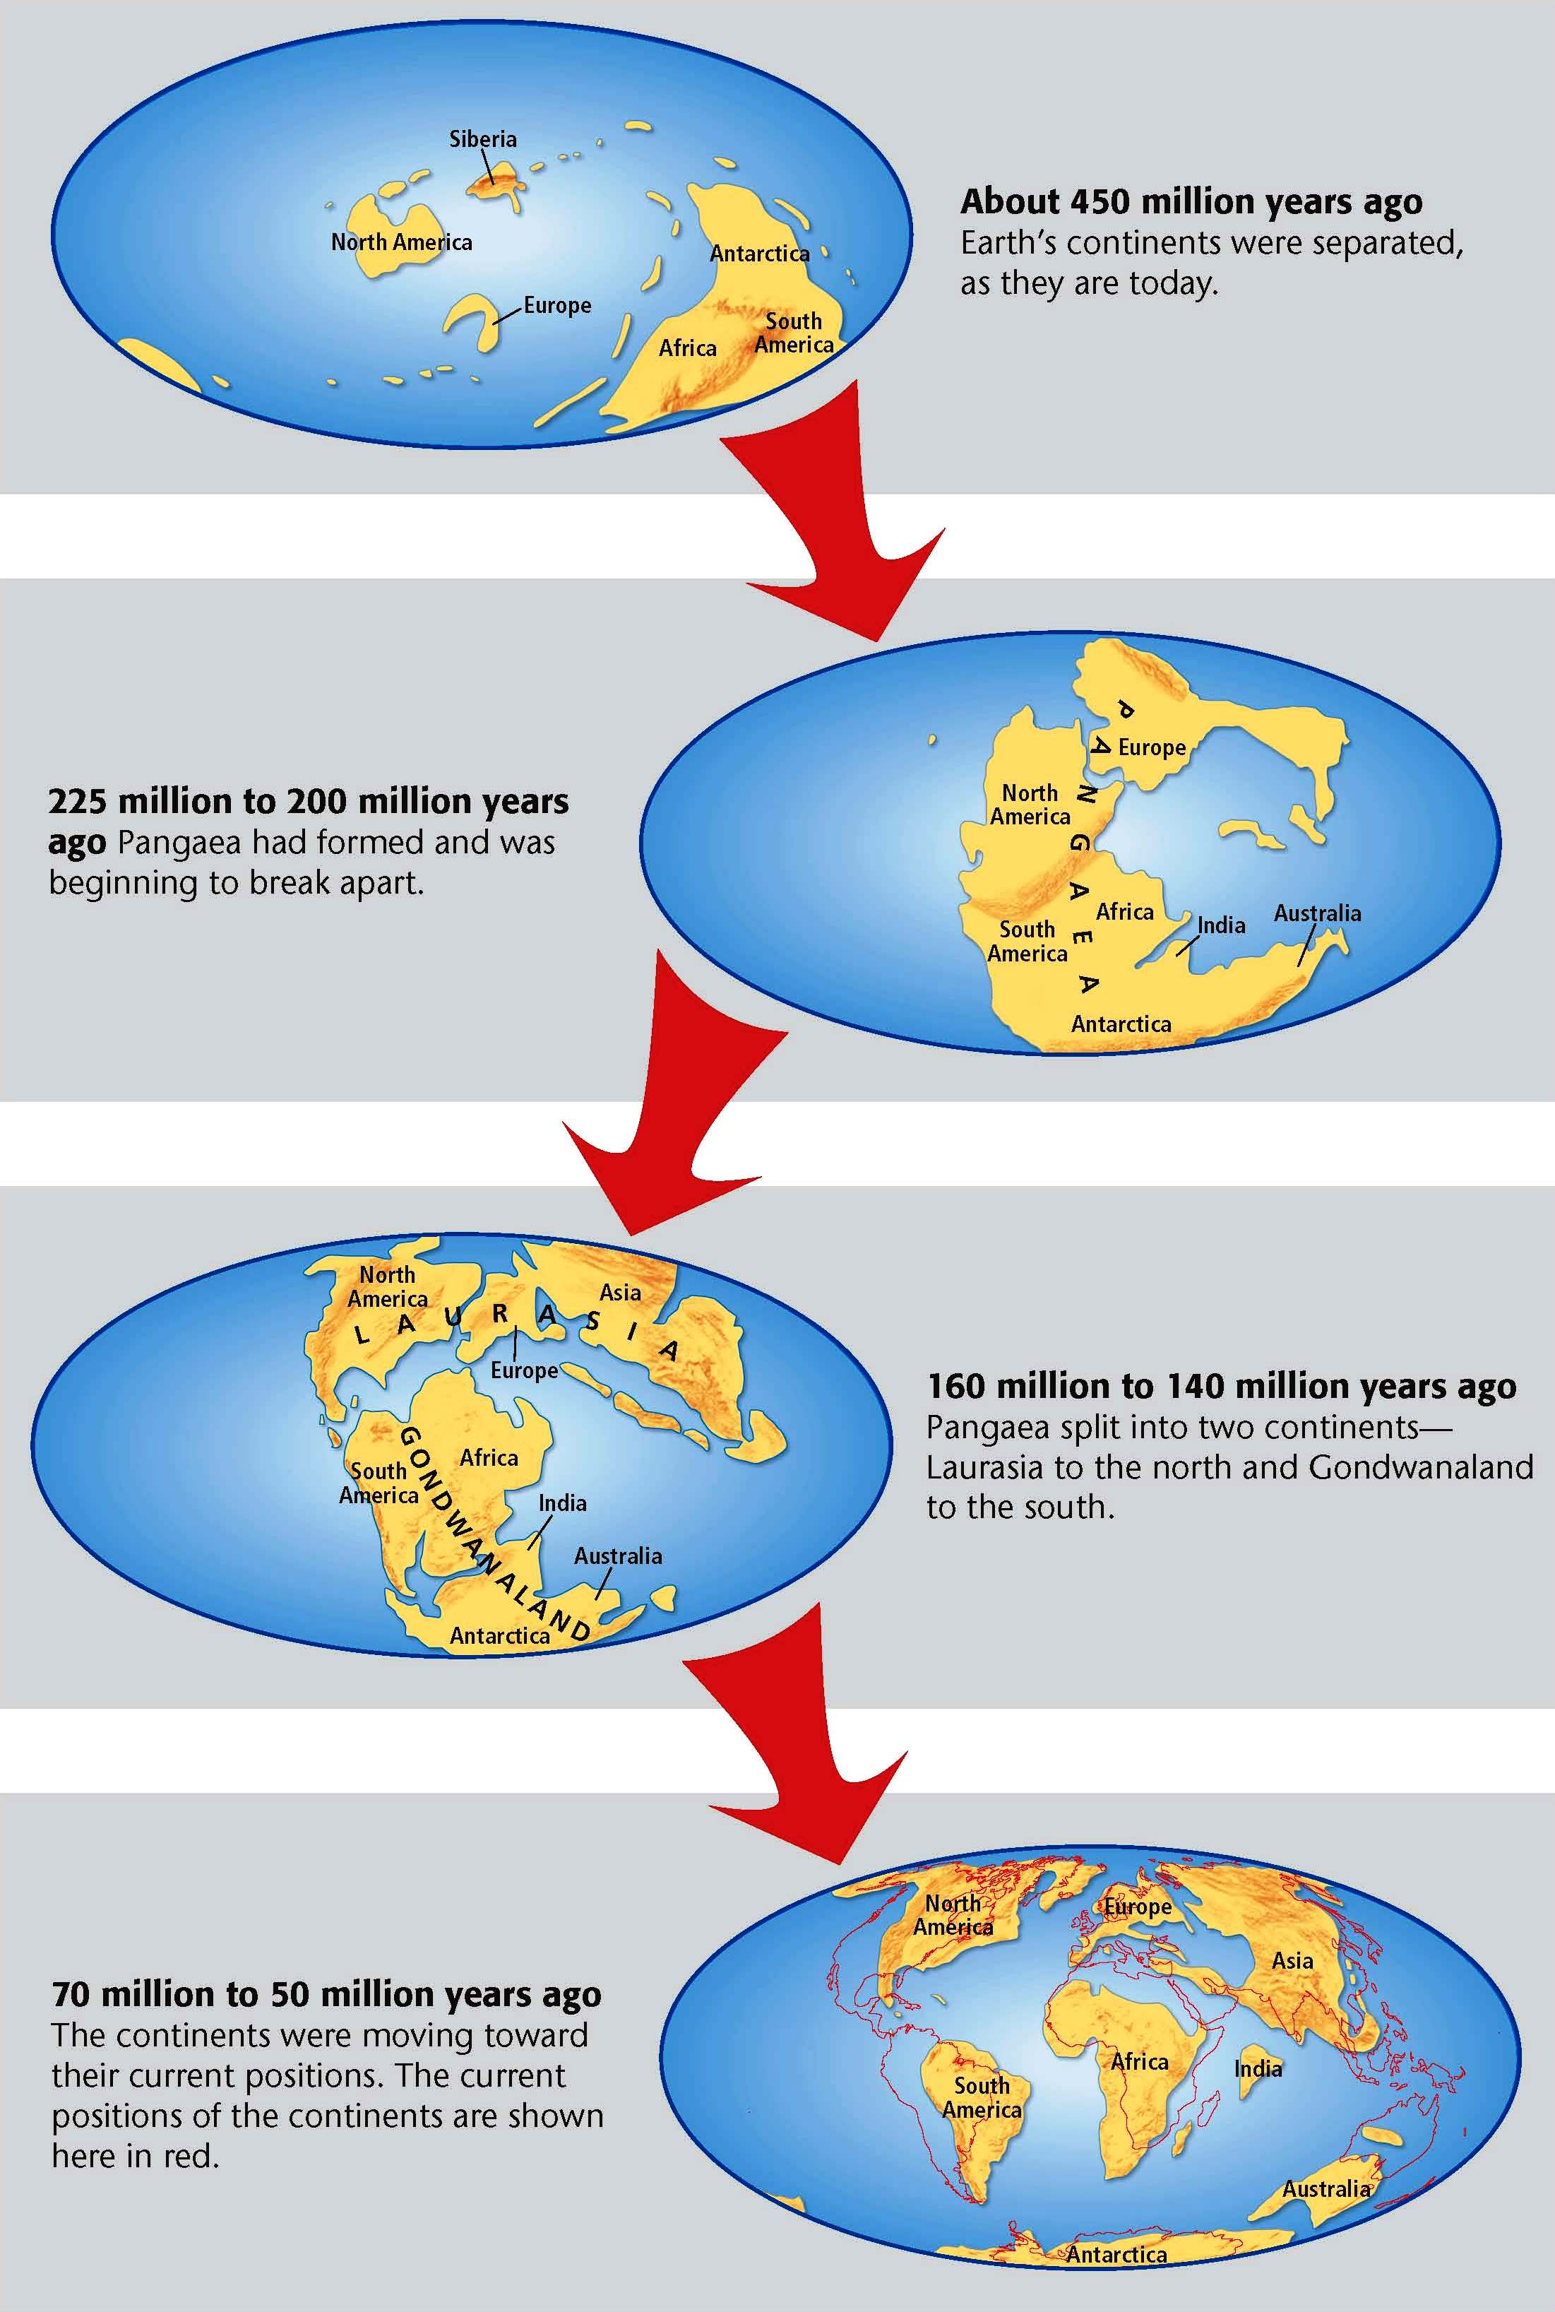
E. The _______________ Continents
- Slowly, the continents moved into their _______________ positions.

- As the continents _______________, they collided with terranes and other continents. New mountain _______________ , such as the _______________ _______________, the _______________, and the _______________, formed. Tectonic plate motion also caused new _______________ to open up and caused others to close.

F. _______________ of the Future
- As tectonic plates _______________ to move, Earth’s geography will change _______________.

- Scientists predict that in 250 million years, the continents will come together again to form a _______________ _______________.

