Unit 6.4: Earthquakes-How and Where Earthquakes Happen

I. _______________ _______________ Happen
A. _______________-a movement or trembling of the ground that is caused by a _______________ release of energy when rocks along a fault move.
- _______________ _______________-sudden return of elastically _______________ rock to its undeformed shape
- Geologists think that _______________ are the result of elastic rebound as shown in the diagram below:
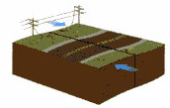
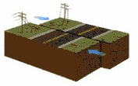
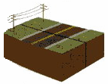

Step 1: Two blocks of crust pressed against each other are under stress but do not move because friction holds them in place.
Step 2: As stress builds up at the fault, the crust deforms & bends out of shape.
Step 3: The rocks break at their weakest point along the fault & then rebound as they snap back into their original shape, which causes an earthquake.

B. _______________ of an Earthquake  - _______________-the location within Earth along a fault at which the first motion of an earthquake occurs  - _______________-the point on Earth’s surface above an earthquake’s starting point, or focus  - Although the focus depths of _______________ vary, 90% of continental earthquakes have a shallow focus.  - Earthquakes that have deep foci usually occur in _______________ zones.  - _______________ that cause the most damage usually have shallow _______________ and occur at fracture/fault zones. | 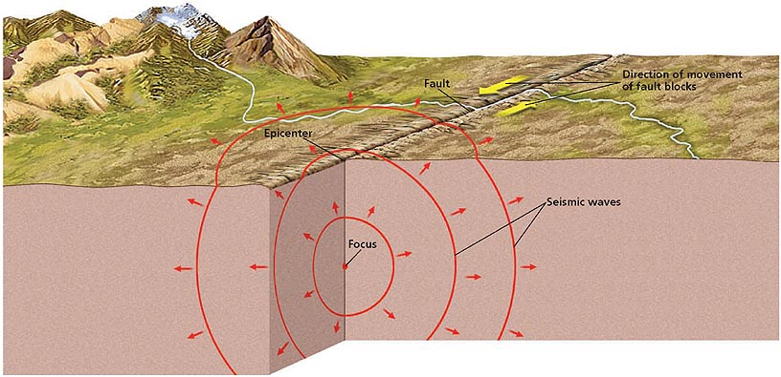

II. _______________ Waves
A. General Info
- As rocks along a fault slip into new positions, the rocks _______________ energy in the form of _______________ called _______________ waves.
- _______________ waves travel outward in all directions from the focus through the _______________ rock.
- Each type of wave travels at a _______________ _______________ and causes different _______________ in Earth’s crust.

B. _______________ _______________
- _______________ _______________-a seismic wave that travels through the body of a medium. There are 2 types of body waves:
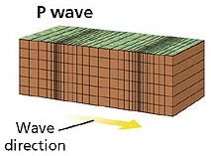
→ _______________ _______________-a primary wave, or compression wave; a seismic wave that causes _______________ of rock to move in a back-and-forth direction _______________ to the direction in which the wave is _______________. P waves are the fastest seismic waves and can travel through solids, liquids, and gases. The more _______________ the material is, the _______________ the P wave travels through it.

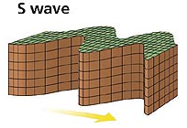
→ _______________ _______________-a secondary wave, or shear wave; a seismic wave that causes particles of rock to move in a side-to- side direction _______________ to the direction in which the wave is traveling. S waves are the _______________-fastest seismic waves and can _______________ travel through _______________.

C. Surface Waves
- _______________ _______________-a seismic wave that travels along the _______________ of a medium and that has a stronger effect near the surface of the medium than it has in the interior
- Surface waves form from _______________ along a _______________ fault or from the conversion of energy when P waves or S waves reach Earth’s surface.
- Although _______________ waves are the slowest-moving seismic waves, they can cause the _______________ _______________ during an earthquake.
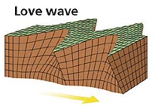
- There are also 2 types of surface waves:
→ _______________ _______________ (_______________ _______________)-surface waves that cause rock to move side-to-side and perpendicular to the direction of the wave.

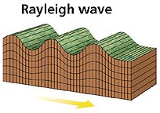
→ _______________ _______________ (_______________ _______________)- surface waves cause the ground to move with an elliptical, rolling motion.

III. _______________ _______________ and the _______________ _______________
A. _______________ Internal _______________
- By studying the _______________ and _______________ of seismic waves, scientists can learn more about the makeup and structure of Earth’s _______________.
- In 1909, Andrija Mohorovičić discovered that the _______________ of _______________ _______________ increases abruptly at about 30 km beneath the surface of continents, where the _______________ and _______________ meet.
- By _______________ seismic waves, scientists have _______________ Earth’s three _______________ layers (the crust, the mantle, and the core) and Earth’s _______________ _______________ layers (the lithosphere, the asthenosphere, the mesosphere, the outer core, and the inner core).  B. _______________ _______________  - _______________ _______________-an area on Earth’s surface where no direct _______________ waves from a particular earthquake can be detected  - _______________ zones exist because the materials that make up Earth’s interior are not _______________ in rigidity.  - When seismic waves travel through materials of different _______________, they change in both speed and direction.  - S waves do not reach the S wave shadow zone because cannot pass through the _______________ outer core.  - P waves do not reach the P wave shadow zone because of the way the P waves _______________ and they travel through Earth’s interior. | 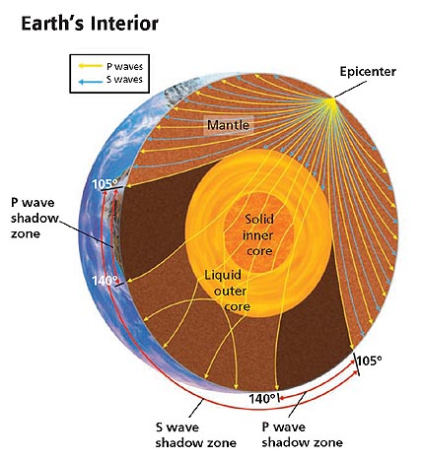
IV. _______________ and Plate _______________
A. _______________ _______________
- Earthquakes are the result of _______________ in Earth’s _______________.
- Most earthquakes occur at or near _______________ plate boundaries, where _______________ on the rock is greatest.
- The three main types of tectonic settings are convergent oceanic environments, divergent oceanic _______________, and _______________ environments.

B. _______________ Oceanic Environments
- At _______________ plate boundaries, plates move toward each other and collide.
- The denser plate moves down, or _______________, into the _______________ under the other plate, causing earthquakes.
- _______________ oceanic boundaries can occur between two oceanic plates or between one _______________ plate and one _______________ plate.

C. _______________ Oceanic Environments
- At the _______________ plate boundaries that make up the mid-ocean ridges, plates are moving _______________ from each other.
- Earthquakes occur along mid-ocean ridges because oceanic lithosphere is _______________ away from both sides of the ridge.

D. _______________ _______________
- Earthquakes also occur at locations where two continental plates _______________, _______________, or move _______________ in opposite directions.
- As the continental plates interact, the rock surrounding the boundary experiences _______________, which causes earthquakes.

V. _______________ Zones
A. _______________ _______________
- _______________- a break in a body of rock along which one block _______________ relative to another.
- _______________ _______________-a region of numerous, closely spaced _______________
- Fault zones form at plate _______________ because of the intense stress that results when plates _______________, _______________, _______________, or _______________ _______________ each other.
- When enough _______________ builds up, movement occurs along one or more of the _______________ faults in the fault zone and sometimes causes major _______________.

B. _______________ Away from Plate Boundaries
- Not all earthquakes result from _______________ along plate boundaries.
- In 1811 and 1812 the most widely felt series of earthquakes in United States history occurred in the _______________ of the _______________ near New Madrid, Missouri.
- In the late 1970s scientists discovered an ancient fault zone _______________ within the crust of the _______________ River region.

