Unit 6.5: Earthquakes-Studying Earthquakes

I. _______________ _______________
- The study of _______________ and seismic waves is called _______________.
- Seismologists use special _______________ equipment to record, locate, and measure earthquakes.
- _______________ an instrument that records _______________ in the ground
- _______________ a tracing of earthquake motion that is recorded by a seismograph
- Seismographs record _______________ types of _______________ _______________-vertical, east-west, and north-south.
- Because they are the fastest, P waves are the first seismic waves to be recorded by a _______________.
- S waves are the second _______________ waves to be recorded, and _______________ waves are the _______________ to be recorded by a seismograph.

II. _______________ _______________  - To determine the distance to an _______________ and the start time of an _______________, scientists consult a lag-time graph and analyze the _______________ times of the P waves and S waves.  - Scientists use _______________ to _______________ the data from several seismograph stations. These _______________ help determine the location of an earthquake by _______________ a location where the wave patterns from each station intersect. | 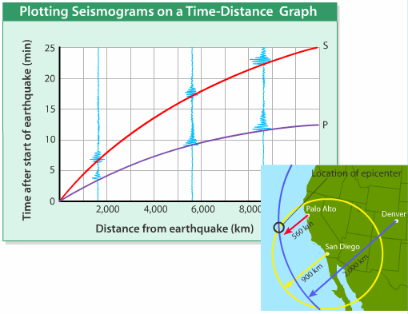

III. _______________ _______________
A. _______________
- _______________-a measure of the strength of an earthquake
- Magnitude is determined by _______________ the amount of ground _______________ caused by an _______________.
- While the _______________ scale was widely used for most of the 20th century, scientists now prefer to use the _______________ _______________ scale.
- Moment magnitude is a measure of _______________ strength based on the _______________ of the area of the _______________ that moves, the _______________ distance that the fault blocks move, and the _______________ of the rocks in the fault zone.

B. _______________
- _______________-the amount of _______________ caused by an _______________
- Before the development of magnitude scales, the size of an earthquake was described in terms of the _______________ effects.
- The modified _______________ scale expresses intensity in _______________ numerals from I to XII and provides a _______________ of the effects of each earthquake intensity.

A Comparison of Earthquake Magnitude and Intensity
Mercalli Scale Intensity | Richter Scale Magnitude | Class | Earthquake effects/witness observations
I | 1.0-1.9 | Minor | Felt by very few people; barely noticeable.
II | 2.0-2.9 | Minor | Felt by a few people, especially on upper floors of very tall buildings.
III | 3.0-3.9 | Minor | Noticeable indoors, especially on upper floors of building 2 floors or more, but may not be recognized as an earthquake.
IV | 4.0 | Light | Felt by many indoors, few outdoors. May feel like heavy truck passing by.
V | 4.1-4.9 | Light | Felt by almost everyone, some people awakened. Small objects moved. trees and poles may shake.
VI | 5.0-5.9 | Moderate | Felt by everyone. Difficult to stand. Some heavy furniture moved, some plaster falls. Chimneys may be slightly damaged.
VII | 6.0 | Strong | Slight to moderate damage in well built, ordinary structures. Considerable damage to poorly built structures. Some walls may fall.
VIII | 6.1-6.9 | Strong | Little damage in specially built structures. Considerable damage to ordinary buildings, severe damage to poorly built structures. Some walls collapse.
IX | 7.0 | Major | Considerable damage to specially built structures, buildings shifted off foundations. Ground cracked noticeably. Wholesale destruction. Landslides.
X | 7.1-7.9 | Major | Most masonry and frame structures and their foundations destroyed. Ground badly cracked. Landslides. Wholesale destruction.
XI | 8.0 | Great | Total damage. Few, if any, structures standing. Bridges destroyed. Wide cracks in ground. Waves seen on ground.
XII | 8.1 or higher | Great | Total damage. Waves seen on ground. Objects thrown up into air.

Magnitude | Estimated Number Each Year
2.5 or less | 900,000
2.5 to 5.4 | 30,000
5.5 to 6.0 | 500
6.1 to 6.9 | 100
7.0 to 7.9 | 20
8.0 or greater | One every 5 to 10 years

