Unit 7.1: River Systems-The Water Cycle

I. Movement of Water on Earth
A. General info
- water cycle-the ____________ movement of water between the atmosphere, the land, and the oceans.
- More than two-thirds of Earth’s surface is covered with water.
- In the _________________, water occurs as an invisible gas. This gas is called water vapor. Liquid water also exists in the atmosphere as small particles in clouds and fog.
- Earth’s water is constantly ________________ from one form to another.

B. Evapotranspiration
- ____________________-the total loss of water from an area, which equals the sum of the water lost by evaporation from the _______________ and other surfaces and the water lost by transpiration from organisms.
- Each year, about 500,000 km3 of water _________________ into the atmosphere. About 86% of this water evaporates from the ocean.
- Water vapor also enters the air by _______________, the process by which plants and animals release water vapor into the atmosphere.

C. Condensation
- Condensation-the change of __________________ from a gas to a liquid.
- When water _________________ rises in the atmosphere, it expands and cools.
- As the vapor becomes cooler; some of it ______________, or changes into tiny liquid water droplets, and forms clouds.

D. Precipitation
- Precipitation-any form of water that ___________ to Earth’s surface from the clouds; includes __________, ___________, ___________, and hail.
- About 75% of all precipitation falls on Earth’s oceans. The rest falls on land and becomes runoff or groundwater.
- Eventually, all of this water returns to the _______________ by evapotranspiration, condenses, and falls back to Earth’s _______________ to begin the cycle again.
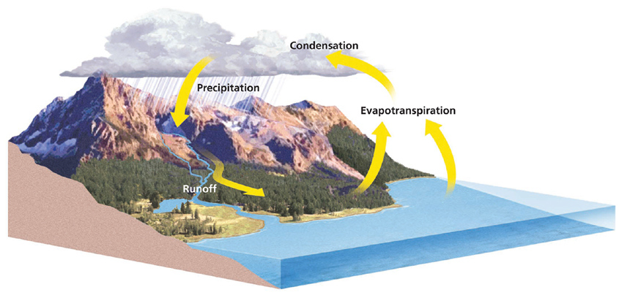

II. Water Budget
A. General Info
- In Earth’s water budget, _________________ is the income. Evapotranspiration and runoff are the expenses.
- The water budget of Earth as a whole is ________________ because the amount of precipitation is equal to the amount of evapotranspiration and __________________.
- However, the _______________ budget of a particular area, called the _________________, is usually not balanced.

B. Factors That Affect the Water Budget
- Factors that affect the local water budget include _____________, _______________, wind, and the amount and duration of rainfall.
- The factors that affect the local water budget vary _________________.
- The local water budget also changes with the __________________ in most areas of Earth.

C. Water Use
- On average, each person in the United States uses about ____________ L (20,890.5 gal) of water each year.
- As the _____________ of the United States increases, so does the ____________ for water.
- About ___% of the water used by cities and industry is returned to rivers or to the oceans as wastewater.
- Some of this wastewater contains harmful materials, such as _____________ chemicals and metals.

D. Conservation of Water
- Scientists have identified two ways to ensure that enough ______________ is available today and in the future.
- One way is through __________________ or the wise use of water resources.
- A second way to ___________________ the water supply is to find alternative methods of obtaining fresh water.
- Desalination-a process of _____________________ salt from ocean water.
- Desalination is ____________________ and is impractical for supplying water to large populations.
- Currently, the best way of __________________ an adequate supply of fresh water is the wise use and _________________ of the fresh water that is now available.

