Unit 7 Section 3: Groundwater-Water Beneath the Surface

I. Properties of Aquifers
A. General Info
- _________________-the water that is beneath Earth’s surface
- _________________-a body of rock or sediment that stores groundwater and allows the flow of groundwater
- Groundwater is an important source of ____________________ in the United States.
- The ease with which water _________________ through an aquifer is affected by many factors, including porosity and permeability.
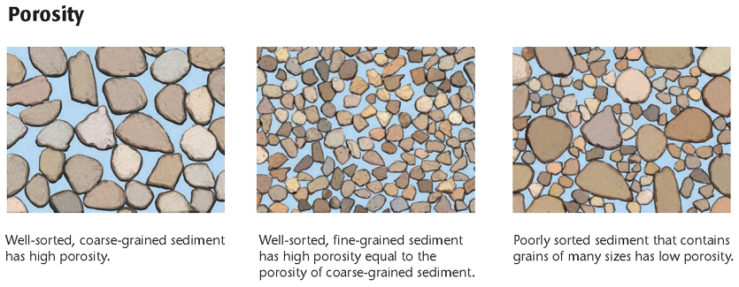
B. Porosity
- Porosity-the _________________ of the total volume of a rock or sediment that consists of open spaces
- One factor that affects porosity is sorting. __________________ is the amount of uniformity in the size of the rock or sediment particles.
- Particle ____________ also affects
porosity. Grain shape also
affects porosity.

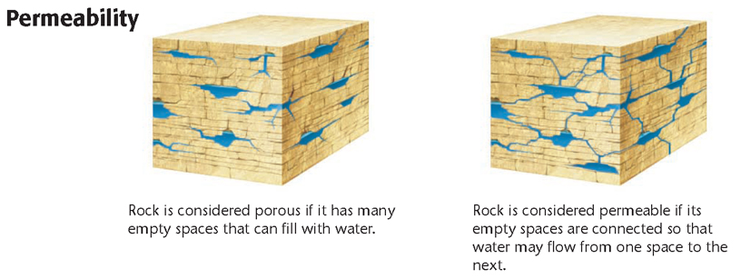
C. Permeability
- ______________-the ability of a rock or sediment to let fluids pass through its _____________ spaces, or pores
- For a rock to be _________________, the open spaces must be connected.
- Permeability is also affected by the size and sorting of the particles that make up a rock or sediment. The larger and better sorted the _______________ are, the more permeable the rock or sediment tends to be.

II. Movement of Groundwater
- Water passes quickly through ____________________ permeable rock and slowly through rock that is less permeable.
- The rate at which groundwater flows _______________________ depends on both the permeability of the aquifer and the gradient of the water table.
- Gradient is the __________________ of a slope.
- The velocity of ________________ increases as the water table’s gradient increases.

III. Zones of Aquifers
A. General Info
- Gravity pulls water down through ______________ and rock layers until the water reaches impermeable rock.
- Water then begins to fill, or ______________, the spaces in the rock above the impermeable layer.
- As more water soaks into the ground, the water level rises ______________________ and forms two distinct zones of groundwater.

B. Zone of Saturation
- water table-the upper ______________ of underground water; the upper boundary of the zone of saturation
- The layer of an aquifer in which the _____________ space is completely filled with water is the zone of saturation.
- The term _________________ means “filled to capacity.”
- The ____________________________ is the lower of the two zones of groundwater.

C. Zone of Aeration
- The zone that lies between the ___________________ table and Earth’s surface is called the zone of aeration.
- The zone of ____________________ is composed of three regions.
- Water is drawn up from the zone of saturation into the _______________________ fringe by capillary action. Capillary action is caused by the _____________________ of water molecules to other materials, such as soil.
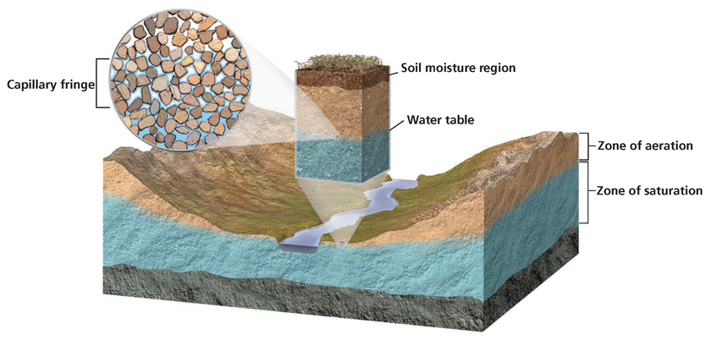

IV. Topography and the Water Table
- The depth of the water table below the ____________________ surface depends on surface topography, the permeability of the aquifer, the amount of rainfall, and the rate at which humans use water.
- Only one water __________________exists in most areas.
- In some areas, however, a layer of ________________________ rock lies above the main water table. Water collects on top of this upper layer and creates a ________________________ water table, which is called a perched water table.
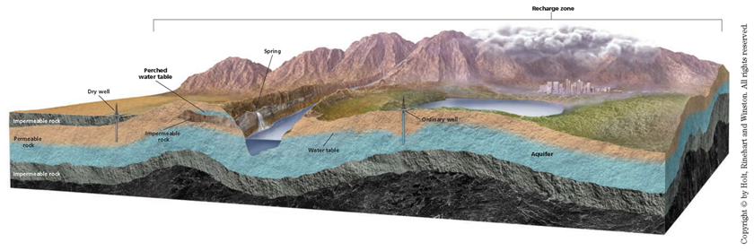

V. Wells and Springs
A. General Info
- Groundwater reaches ________________ surface through wells and springs.
- A well is a hole that is dug to below the level of the _____________ table and through which groundwater is brought to Earth’s surface.
- A _________________ is a ____________________ flow of groundwater to Earth’s surface in places where the ground surface dips below the water table.

B. Ordinary Wells and Springs
- _______________________ wells work only if they penetrate highly permeable sediment or rock below the water table.
- If the rock is not permeable enough, _____________________ cannot flow into the well quickly enough to replace the water that is withdrawn.
- Pumping water from a well lowers the water table around the well and forms a ________________ of depression.
- ____________________ springs are usually found in rugged terrain where the ground surface drops below the water table.
- These springs may not flow ___________________ if the water table in the area has an irregular depth as a result of variable rainfall.

C. Artesian Wells and Springs
- ___________________ formation a sloping layer of permeable rock sandwiched between two layers of impermeable rock and exposed at the surface
- Water in some wells may come from as far away as _____________________ of _________________.
- The permeable rock is the aquifer, and the top layer of impermeable rock is called the caprock.
- Because the water is under pressure, when a well is _______________ through the ________________, the water quickly flows up through the well and may even spout from the surface.
- An _________________ well is a well through which water flows freely without being pumped
- When cracks occur naturally in the caprock, water from the __________________ flows through the cracks. This flow forms artesian springs.

VI. Hot Springs
- Groundwater is heated when it passes through _____________________ that has been heated by magma.
- Hot groundwater that is at least __________________°C and that rises to the surface before cooling produces a _______________ spring.
- When water in a hot spring cools, the water ______________________ minerals around the spring’s edges.
- The deposits form steplike terraces of _________________ called travertine.

VII. Geysers
- Hot springs that periodically erupt from surface_________________ or through small vents are called geysers.
- A ________________ consists of a narrow vent that connects one or more underground chambers with the surface.
- Release of the water near the top of the vent r__________________ the pressure on the superheated water farther down.
- The eruption continues until most of the ________________ and steam are emptied from the vent and chambers.

V. Conserving Groundwater
- Although ____________________ is renewable, its long renewal time limits its supply. Groundwater collects and moves slowly, and the water taken from ____________________ may not be replenished for hundreds or thousands of years.
- Communities often ___________________ the use of groundwater to help conserve this valuable resource.
- Some communities recycle used water. This water is __________________ and may be used to replenish the groundwater supply.
- A __________________ is anywhere that water from the surface can travel through permeable rock to enter an aquifer.
- Recharge zones are environmentally sensitive areas because ___________________ in the recharge zone can enter the aquifer.

