Unit 8.2: Movements of the Oceans – Ocean Currents

I. Factors That Affect Surface Currents
A. General Info
- Current-in geology, a _________________ movement of water in a well-defined ______________, such as a river or stream
- surface current-a horizontal movement of ______________ water that is caused by wind and that occurs at or near the ocean’s __________________.
- Surface __________________ are controlled by three factors: air currents, Earth’s rotation, and the location of the continents.
- Because wind is _________________ air, wind has _________________ energy.
- As energy is __________________ from the air to the ocean, the water at the ocean’s surface begins to move.

B. Global Wind Belts
- Global _________________ belts, such as the trade winds and westerlies, are a major _______________ affecting the flow of ocean surface water.
- In both hemispheres, ______________________ belts push currents westward across the tropical latitudes of all _________________ major oceans.
- Westerlies push ocean ___________________ eastward in the higher latitudes of the Northern and Southern Hemispheres.

C. Continental Barriers
- The continents are another major _____________________ on surface currents.
- The continents act as __________________ to surface currents.
- When a surface current flows against a _______________________, the current is deflected and divided.

D. The Coriolis Effect
- __________________ effect-the apparent curving of the path of a moving object from an otherwise straight _____________ due to Earth’s rotation
- Wind belts and ocean currents follow a _______________ or circular pattern that is caused by Earth’s rotation.
- _________________- a huge circle of moving ocean water found above and below the equator
- Wind belts and the ______________ effect cause huge circles of moving water, called gyres, to form.
- In the Northern ________________, water flow in gyres is to the right, or ________________. In the Southern Hemisphere, the flow is to the left, or counterclockwise.

II. Major Surface Currents
A. Equatorial Currents
- Warm equatorial _________________ are located in the ____________________, Pacific, and Indian Oceans.
- Each of these oceans has two warm-water _________________ currents that move in a westward direction.
- Between these westward-flowing __________________ lies a weaker, eastward-flowing current called the Equatorial Countercurrent.

B. Currents in the Southern Hemisphere
- In the most southerly regions of the___________________, constant westward winds produce the world’s largest current, the ____________________ Circumpolar Current, also known as West Wind Drift.
- No continents interrupt the movement of this ______________________ that completely circles Antarctica and crosses all three major oceans.

C. Currents in the North Atlantic
- ______________ Stream-the swift, deep, and warm ____________________ current that flows along the eastern coast of the United States toward the north
- South of ___________________, the Gulf Stream widens and slows until it becomes a vast, slow-moving warm current known as the ___________________ Atlantic Current.
- Near ____________________ Europe, the North Atlantic Current splits.
- The Gulf Stream, the North _________________ Current, the Canary Current, and the North Equatorial Current form the North Atlantic __________.
- At the center of this gyre lies a vast area of calm, warm water called the ___________________ Sea.

D. Currents in the North Pacific
- The patterns of currents in the North Pacific is similar to that in the North Atlantic.
- The warm _________________ Current, the Pacific equivalent of the Gulf Stream, flows northward along the east coast of Asia. This current then flows toward North America as the North Pacific Drift.
- It eventually flows southward along the________________________ coast as the cool California Current.
Figure 1:
Major Surface Currents

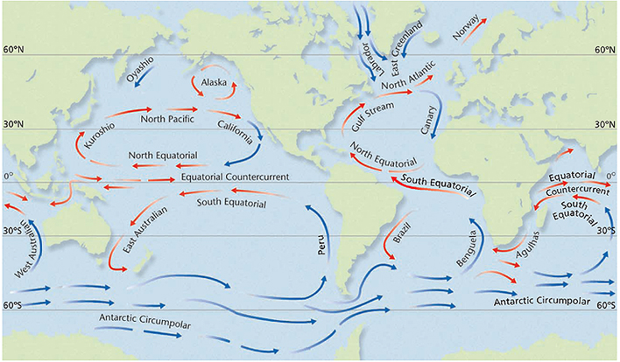

III. Deep Currents
A. General Info
- _________ current-a streamlike movement of ocean water far below the surface
- Deep currents form as cold, dense water of the ___________ regions sinks and flows beneath warmer ocean water.
- The movement of polar _______________ is a result of differences in density.
- __________________ determines density. ________________, too, determines the density of water.

B. Antarctic Bottom Water
- The temperature of the water near ________________is very cold, −2°C. The water’s salinity is high. These two factors make the water off the coast of __________________ the densest and coldest ocean water in the world.
- This dense, ______________________ water ____________ to the ocean bottom and forms a deep current called the Antarctic Bottom Water.

C. North Atlantic Deep Water
- In the North Atlantic, south of ____________________, the water is very cold and has a high salinity. This cold, salty __________________ forms a deep current that moves southward under the northward flowing _______________ Stream.
- The dense, highly saline water of the ________________________ Sea forms a deep current as it flows through the strait of _____________________ and into the less dense Atlantic Ocean.

D. Turbidity Currents
- _______________ current-a strong current caused by an ________________________ landslide.
- The sediment causes the water to become cloudy, or _________________, and denser than the surrounding water.
- The dense water mass of the _______________________ current moves beneath the less dense, clear water.

