Unit 9.2: The Atmosphere – Solar Energy and the Atmosphere

- Radiation
  - All of the energy that Earth gets from the sun travels through space as _________________.
  - Radiation includes all forms of ________________ that travel through space as waves.
  - Radiation moves through space as ___________ at a very high speed—approximately _______km/s.
  - electromagnetic spectrum-all of the frequencies or wavelengths of electromagnetic radiation
  - The distance from any point on a wave to the ________________ point on the next wave, for example from crest to crest, is called the _________________________ of a wave.
  - The various types of radiation differ in the _________________ of their waves.
- The Atmosphere and Solar Radiation
  - General Info
    - As solar _____________ passes through Earth’s atmosphere, it affects the radiation in several ways.
    - Most of the solar rays that reach the lower atmosphere, such as ______________ and infrared waves, have _____________ wavelengths.
  - Scattering
    - Clouds, dust, water droplets, and as __________________ in the atmosphere ______________ the paths of radiation from the sun and cause scattering.
    - ___________________ occurs when particles and gas molecules in the atmosphere reflect and bend solar rays.
    - This ___________________ causes the rays to travel out in all directions without changing their wavelength.
  - Reflection
    - __________________-the fraction of solar radiation that is reflected off the surface of an object.
    - The amount of energy that is absorbed or __________________ depends on characteristics such as __________________, ________________, _____________________, volume, mass, transparency, state of matter, and specific heat of the material on which the solar radiation falls.
    - The intensity and amount of time that a surface material _______________ radiation also affects how much energy is reflected or absorbed.
- Absorption and Infrared Energy
  - General Info
    - Solar radiation that is not _________________ is absorbed by rocks, soil, water, and other surface materials.
    - Gas molecules, such as water vapor and __________________ dioxide, in the atmosphere absorb these infrared rays.
    - The absorption of thermal energy from the ground _______________ the lower atmosphere and keeps Earth’s surface much ____________________ than it would be if there were no atmosphere.
- The Greenhouse Effect
  - ____________________ the warming of the surface and lower atmosphere of Earth that occurs when carbon dioxide, water vapor, and other gases in the air absorb and reradiate radiation
  - Earth’s atmosphere slows the escape of energy that ___________________ from Earth’s surface. 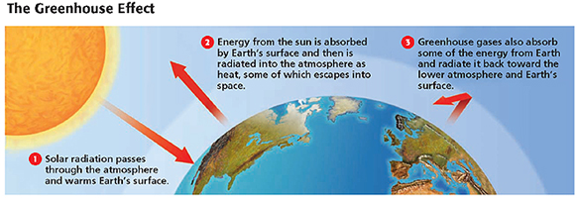
- Human Impact on the Greenhouse Effect
  - Generally, the amount of solar energy that enters Earth’s _______________________ is about equal to the amount that escapes into space.
  - However, human ________________, in addition to natural causes, are _________________ this balance and are causing the average temperature of the atmosphere to increase.
  - Increases in the amount of ____________________ dioxide may intensify the greenhouse effect and may cause Earth to become warmer in some areas and cooler in others.
- Variations in Temperature
  - General Info
    - _____________________ from the sun does not heat Earth equally at all places at all times.
    - Earth’s surface must absorb energy for a time before enough energy has been ____________________ and reradiated from the ground to change the temperature of the atmosphere.
    - The temperature of the ___________________________ in any region on Earth’s surface depends on several factors, including latitude, surface features, and the time of year and day.
  - Water in the Air and on the Surface
    - Because water vapor ____________________ heat, the amount of water in the air affects the temperature of a region.
    - Land areas close to large bodies of ___________ generally have more moderate temperatures
    - The _________________ patterns in an area also affect temperature.
  - Latitude and Season
    - Latitude is the main _____________ that affects how much solar energy reaches any point on Earth’s surface.
    - Because Earth is a sphere, the sun’s rays do not strike all areas at the same ____________. Rays are divided into two major categories based on the ________________ at which they strike Earth.
    - ______________ Rays- strike the earth near the equator, providing direct light that is spread over a small area. As a result, the energy that reaches the equator is more intense, so average seasonal temperatures are higher near the equator than near the poles.
Oblique
Rays
    - ______________ Rays- Strike the Earth closer to
the poles, providing less direct light that is spread out
over a larger area. As a result, the energy that reaches
these areas is more diffuse and average seasonal temperatures are lower.
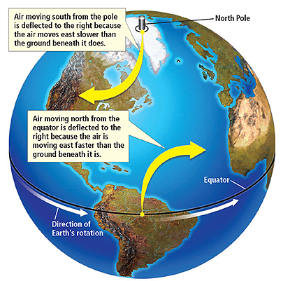
  - Convection
    - _____________________-the movement of matter due to differences in density that are caused by temperature variations, usually due to gases or liquids being heated unevenly
    - The __________________ cycle in which cold air sinks and warm air rises warms Earth’s atmosphere evenly.
    - The atmospheric _________________ is lower _________________ a mass of warm air.
    - As _________________, cool air moves into a low-pressure region, the less dense, warmer air is pushed upward.
    - These ____________________ differences, which are the result of the unequal heating that causes convection, create winds.

