Unit 9.3: The Atmosphere – Atmospheric Circulation

- The Coriolis Effect
  - _______________-the curving of the path of a moving object from an otherwise straight path due to Earth’s rotation
  - The circulation of the atmosphere and of the ocean is affected by the rotation of Earth on its axis. Winds that blow from high pressure areas to lower-pressure areas curve as a result of the coriolis effect.
  - In general, the coriolis effect is detectable only on objects that move very fast or that travel over long distances.
- Global Winds
  - General Info
    - Each hemisphere contains three looping patterns of flow called__________________.
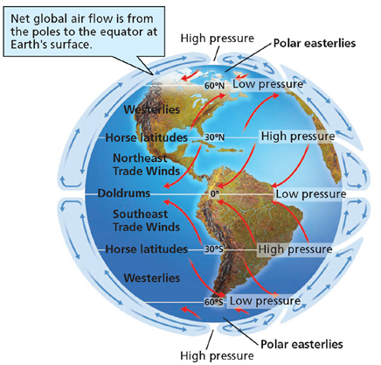
    - Each convection cell correlates to an area of Earth’s surface, called a________________, which is characterized by winds that flow in one direction.
    - These winds are called____________.
  - Trade Winds
    - ___________________- a prevailing wind that blows from east to west from 30º latitude to the equator in both hemispheres
    - Like all winds, trade winds are named according to the direction from which they flow.
    - In the Northern Hemisphere, the trade winds flow the northeast and are called the northeast trade winds. In the Southern Hemisphere, they are the southeast trade winds.
  - Westerlies
    - ________________- prevailing winds that blow from west to east between 30º and 60º latitude in both hemispheres
    - Between 30º and 60º latitude, some of the descending air moving toward the poles is deflected by the coriolis effect.
    - In the Northern Hemisphere, the ___________ are the southwest winds. In the Southern Hemisphere, they are the northwest winds.
  - Polar Easterlies
    - __________________-prevailing winds that blow from east to west between 60 and 90 latitude in both hemispheres
    - Surface winds created by the polar high pressure are deflected by the coriolis effect and become the polar easterlies.
    - Where the polar easterlies meet warm air from the westerlies, a stormy region known as a_____ forms.
- Wind and Pressure Shifts
  - As the sun’s rays shift northward and southward during the changing seasons of the year, the positions of the pressure belts and wind belts shift.
  - Although the area that receives direct sunlight can shift by up to 46 º north and south of the equator, the average shift for the pressure belts and wind belts is only about _______ of latitude.
  - However, even this small change causes some areas of Earth’s surface to be in different wind belts during different times of the year.

