1. Example of a physical change

2. The ability to do work or cause change describes

3. Example of a chemical change

4. Fireworks exploding in the sky and giving off light are an example of

5. The change in which ice absorbs energy and melts is a(n)

6. Butter melting in a pan is a physical change that absorbs energy.

7. The ability of iron to rust is a(n) ______________ property.

8. ___________ is the study of matter and the changes in matter.

9. Anything that has mass and takes up space is called

10. All elements are made of basic particles called

11. What holds atoms together in a molecule?

12. H₂O, CO₂, and C₁₂H₂₂O₁₁ are all examples of chemical

13. How do liquid water, ice, and water vapor differ from each other?

14. Soil, a salad, and sugar water are all examples of

15. The volume of an irregular object can be measured by

16. The measurement of how much mass is contained in a given volume is called

17. The density of a block of wood with a volume of 50 cubic centimeters and a mass of 50 grams is

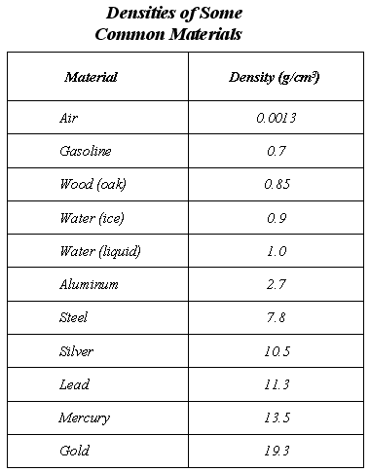

18. What is the mass of 150 cm³ of liquid water?

19. If a sample of a material has a mass of 21 grams and a volume equal to 2 cm³, could it be one of the substances listed in the table?

20. If gasoline is poured carefully into liquid water, will it sink or float?

21. The measurement of how much mass is contained in a given volume is called

22. In the laboratory, volumes of liquid are usually measured with a(n)

23. The SI unit for mass is the

24. The tarnishing of metal is an example of a(n) ____________________ change.

25. Dissolving a spoonful of sugar in tea or coffee is an example of a(n) ____________________ change.

26. ____________________ energy, the total energy of the motion of all the particles in an object, naturally flows from warmer matter to cooler matter.

27. A(n) ____________ change releases energy.

28. The law of ______________ of mass states that in any physical or chemical change, matter is neither created nor destroyed.

29. The form or appearance of matter is altered during a(n) _____________ change.

30. A volume of 100 milliliters is the same as a volume of ____________________ cubic centimeters.

31. If you drop a marble into a glass of water, the marble will sink because its ____________________ is greater than that of water.

