What is Matter Made of?
- For _______________ people tried to _______________ what _______________ was made of.
- Around _______________ B.C. a Greek _______________ named _______________ proposed that it was made up of four elements – _______________, _______________, _______________, and _______________.
- This _______________ was accepted for more than _______________ years.
- Now we know that matter is actually the _______________ of _______________ types of _______________ called _______________.
Elements
- Experiments in the late _______________ began to show that matter was actually made up of _______________ than just _______________ elements.
- _______________ know that all matter in the universe is made of more than _______________ different substances called _______________.
- An _______________ is a _______________ that _______________ be _______________ down into any other substances by _______________ or _______________ means.
- _______________ are the simplest _______________.
- All elements have specific _______________ and _______________ properties that help to _______________ it.
- Elements are represented by _______________- or _______________-letter symbol called _______________ _______________.
  - C=_______________, O=_______________, Au=_______________, Na=_______________
Atoms
- The _______________ _______________ of _______________ explains that all matter is made of _______________.
- An atom is the _______________ particle from which all _______________ are made.
- Atoms _______________ of a _______________ charged _______________, and a _______________ charged _______________ _______________.
- Each atom has different _______________ due to the differences in the _______________ and _______________ cloud.
Molecules
- Atoms of most _______________ are able to _______________ with other _______________.
- When _______________ combine, they form a _______________ _______________.
- _______________ bonds are an _______________ force _______________ two _______________.
- _______________ combine to form _______________ particles called _______________.
- A _______________ is a group of _______________ or _______________ _______________ held together by _______________ _______________.
- For example, water molecules are made up of two _______________ atoms that are _______________ to one _______________ atom. _______________ _______________ that we breathe is a _______________ of _______________ _______________ atoms.
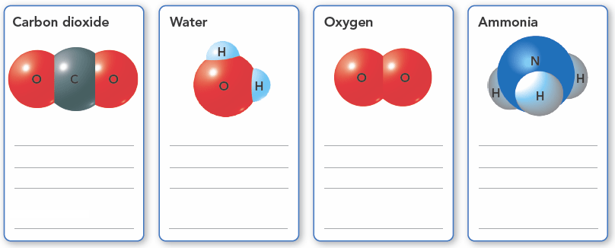
Compounds
- _______________, _______________, and _______________ _______________ are all _______________.
- A _______________ is a _______________ made of _______________ or more elements that are chemically _______________ in a set _______________.
- Compounds are _______________ by _______________ _______________
Chemical Formulas
- _______________ formulas show the _______________ in the _______________ and the _______________ of _______________.
  - For example: _______________ The 2 below the O for oxygen tells you that the ratio of carbon atoms to _______________ atoms is 1 to 2. If there is no _______________ after an _______________ symbol, it is understood that the _______________ is 1.
- A _______________ number of _______________ in a _______________ represent a different _______________.
  - For example: The formula for _______________ _______________ is _______________. Here the set ratio of carbon atoms to oxygen _______________ is 1 to 1.
- When elements chemically combine, they form _______________ with _______________ different from those of the _______________
  - For example: When _______________ combines with _______________ it creates _______________ _______________. Copper sulfides _______________ are _______________ different from both _______________ and _______________.
Mixtures
- _______________ and _______________ are substances, but most _______________ are _______________.
- A _______________ is made of _______________ or _______________ substances that are _______________ in the same place, but their _______________ are not _______________ _______________.
- Mixtures differ from _______________. Each _______________ in a _______________ keeps its own _______________.
- Also, the _______________ of a _______________ are _______________ combined in a set _______________.
Heterogeneous Mixtures
- A _______________ mixture is one where you can see the different parts and they can be _______________ _______________ out.
- Sand from the beach is an example of a _______________ mixture. You can separate out the pieces of _______________, _______________, and _______________ of _______________.
- A _______________ is another example. You can easily _______________ and _______________ pieces of _______________, _______________, _______________ and other _______________.
Homogeneous Mixtures
- The substances in a _______________ mixture are so evenly _______________ that you _______________ see the different parts.
- It is _______________ to _______________ the parts of a _______________ mixture.
- _______________ is a _______________ mixture of _______________.
- You know _______________ is present because you are able to _______________, but you _______________ identify where the _______________ is in the _______________.
- A _______________ is another example of a _______________ _______________.
- _______________ can be _______________, _______________ or even _______________.
- _______________Since the substances in a mixture keep their _______________, you can use those properties to _______________ a _______________ into parts.
- Methods used to separate the parts of a mixture, include _______________, _______________, _______________, and _______________ _______________.
